

Final Year Project

Lyrics Grabber

**By**

Raj Kumar Rai

NP000051

NP3F1801IT

A report submitted in partial fulfillment of the requirements of Asia Pacific University of Technology and Innovation for the degree of

B.Sc. (Hons) Information technology

Supervised by Mr.RN THAKUR

2nd Marker: Dr Swati Sha

Oct-26-2018

**Abstract**

This document is the investigation report on the project ‘Lyrics Grabber’ which is a proposed system to get the lyrics of the song. The reports describe it in context of Nepal who is fond of the music. And the further describe the problems faced by the people in getting the lyric of a song. This report gives walkthrough of the project gives the reader general ideas about the importance of the development of the application ‘LyricsGrabber’ along with its objectives. The major deliveries of the project are the mobile application as a project plan. Different research on the domain and the technical part has been carried out in the application based on the literature review from the past documents and articles. Many researches have been carried out in the technical part so which can be helpful for development of the project. The project has been carried out on the basis of the chosen system development methodology which is Waterfall method. Many different types of data gathering method have been used to fulfill the project. Proper data validation has been put as described. From the study of the report the reader will find out the proposed system.

Contents

1. Introduction 1

1.2 Background of the project 1

1.2.1 Problem context 1

1.2.2 Rational 2

1.3 Potential benefits 2

1.3.1 Tangible benefits 2

1.3.2 Intangible benefits 2

1.4 Targeted user 2

1.5 Scope and objectives 3

1.5.1 Amis 3

1.5.2 Objects 3

1.6 Deliverables – Functionality of the proposed system 3

1.7 Nature of challenges 3

1.8 Overview of this project 4

Chapter 1: Introduction 4

Chapter 2: Literature Review 4

Chapter 3: System Development Methodology 4

Chapter 4: Development/Deployment 4

Chapter 5: Primary Research 4

Chapter 6: Requirement Validation 4

Chapter 7: Conclusion 5

References: 5

Appendix: 5

2. Literature review 7

2.1 Introduction 7

2.2 Domain Research 7

2.3 Technical research 8

3. System Development Methodology 8

3.1 About Methodology 9

3.2 Selecting Methodology 9

3.3 Waterfall methodology 9

3.2.1 Prototyping System Development Methodology 13

3.2.2 Phases of Prototyping System Development Methodology 15

3.2.3 Situation where Prototyping is most suitable 17

3.2.4 Justification 17

4. Development and Deployment 18

4.1 Programming Language Chosen 18

4.4 Libraries chosen / Tools chosen 23

4.6 Conclusion 26

5. Primary Research 26

5.1 Background Introduction 26

5.3 Selected data gathering methods for proposed project 29

6. Requirement validation 31

6.1Questioner data analysis 31

Chapter 7: System Architecture 43

7.1 Introduction 43

7.2 Abstract Architecture 44

7.2.1 System Design 44

7.2.1.1 Use Case Diagram 44

7.2.1.2 Use Case Specification 45

7.2.1.3 Class Diagram 48

7.2.1.4 Activity Diagram 49

7.2.1.5 Sequence Diagram 52

7.2.3 Interface Design 55

Chapter 8: Project Plan 61

8.1 Release Plan 61

8.1.1 Version 1.0 61

8.1.2 Version 2.0 61

8.2 Test Plan 62

8.2.1 Unit Testing 62

9. Implementation 64

9.1 Screenshot 64

9.1.1 Start Up 64

9.2 Sample codes 70

10 System Validation 74

10.2 User Acceptance Testing 74

11. Reflection 78

11.1 Critical evaluation 78

11.2 Limitations 78

11.3 Future Enhancement 78

Conclusion 79

12. Appendix 80

12.1Questionnaire 80

Figure 1: waterfall method 10

Figure 2:: Prototyping System Developing Methodology 14

Figure 3: design 16

Figure 4: JAVA 19

Figure 5: NetBeans 20

Figure 6 : Use case Diagram of Lyrics Grabber 48

Figure 7: Class Diagram of Lyrics Grabber 52

Figure 8: activity diagram of play song 53

Figure 9: activity diagram of download song 54

Figure 10: activity diagram of shows lyrics 55

Figure 11: sequence diagram of play song 56

Figure 12: sequence diagram of download lyrics 57

Figure 13: sequence diagram of show lyrics 58

Figure 14: interface of start up 59

Figure 15: interface of installation 60

Figure 16: interface of downloading lyrics 61

Figure 17: interface of downloading 62

Figure 18: interface of lyrics downloading 63

Figure 19: interface design of shows lyrics 64

Figure 20: Start up 68

Figure 21: installation 69

Figure 22: Home 70

Figure 23: Download lyrics 71

Figure 24: Downloading lyrics 72

Figure 25:Lyrics show 73

Figure 26: Start up code 74

Figure 27: Download code 74

Figure 28:Shows Lyrics 75

Figure 29: Main activity 75

Figure 30: Song ID tracker code 76

List of table

Table 1: Use case 47

Table 2: Download specification 48

Table 3: Shows lyrics 49

Table 4: testing of download lyrics 64

Table 5: unit testing of shows lyrics 64

Table 6: Validation download lyrics 75

Table 7: Validation of shows lyrics 75

**Acknowledgement**

The research that has been done here was a total new experience which gave me chance to get the knowledge and the research was based on the support of the supervisor. RN Thakur I would like to give ma gratitude and thanks to the people and my colleagues who encouraged me and help to do the research. Due to their assistance and every individual and their efforts, the research reached to its completion, thus I am very grateful and thankful to them for supporting me and giving their time on me.

# 1. Introduction

Music plays an important role in the socialization of children, adolescents, and adult. Popular music is present almost everywhere, and it is easily available through the radio, various recordings, the Internet, and new technologies, allowing adolescents to hear it in diverse settings and situations, alone or shared with friends.

And this project is about to get Lyrics of songs “LYRICS GRABBER”. It is the application which helps to generate the lyrics of a song. The project title refers the whole meaning of the entire project. (Lyrics grabber) it is a kind of app which grabs the lyrics of the song and provides to user. This app is best for the music lover and artists who are enrolled in the music field its main target is to reduce effort for the people who are fond of music.

Nepal is an underdeveloped landlocked country from south Asia. Unstable political situation is the major problem of the backwardness of the country. Recently in Nepal there has not been any progress in music industry. Nepal is full of different culture and religion and the society, culture has their own musical influence some famous music instrument of country were Sarangi, Madal e.tc. Due to the influence of the music from past history of Nepalese society people now days have started to listen western music which had made huge impact. Now day’s people have started to play western music in many places for entertainment and fun.

## 1.2 Background of the project

### 1.2.1 Problem context

As per the research Music with lyrics helps to reduce aggression. Many paper tests have shown whether the prosaically lyric effect generalizes to reducing customer aggression in the workplace. A field experiment involved changing the hold music played to customers of a call centermost of the people listen to their favorite music at least one time per day.

And people who are fond of music cannot get to know about the lyrics. As we know all the people have different taste of music people they want to know about the lyrics of song. The majority of people listening music in their daily lives includes lyrics. Many people cannot find the lyrics of particular song for them this mobile app will help them to get lyrics on their smart phone easily. This consumes more time to get the lyrics of a song we have to search lyrics of each and every song thou there are high chances of getting wrong lyrics through internet many artist have been facing the same problem. This shows how more repetitive songs lyrically are processed more fluently and thus adopted more broadly and quickly in the marketplace and one of the problems is the lyrics of the same song have been put on different in different websites which make confusing to the user. Due to this there are many people who find difficulties to get the lyrics of a particular song.

In past days we have to hard to get the lyrics of song we have to search lyrics of each and every song. Which consumes more time there are many people who find to get the lyrics of a particular song and to get to know about song lyrics many artist have find that it’s hard to get the lyrics of the song of different nation they have to surf and consume more time to get the lyrics .Even the artist musician I know faces the same problem to find the lyrics of the particular song.

And people who are fond of music cannot get to know about the lyrics as we know all the people have different taste of music and all people like the music get to know about the lyrics but some are busy and for them this mobile app will help to get the music lyrics on their smart phone easily.

### 1.2.2 Rational

From above definition that stated the problems of getting the lyrics of typical song “LYRICS GRABBER” will be a mobile application which will helps to find the lyrics of a song which are in playlist which will saves time and easy to get the lyrics of particular song.

## 1.3 Potential benefits

### 1.3.1 Tangible benefits

* Time saving
* Easy to use
* Easy to access

### 1.3.2 Intangible benefits

* Very easy to get the lyrics of song than searching in browser.
* It will be very useful for music artist.

## 1.4 Targeted user

The main focus for this app is for all the ages because all the people hear the song but mainly targeted user is music lover and the musician. The primary user will be musician who plays music in shows who have to create their song list while playing and have to gather many lyrics according to their generic and the secondary user are the user who is fond of hearing song .

## 1.5 Scope and objectives

### 1.5.1 Amis

The main aim of this research is to make easy for the people to get lyrics of the song they want and can be translate its meaning in all the language and people can know the actual meaning of the lyrics. So it will be easy access to get the lyrics of every song easily and less effort.

### 1.5.2 Objects

There are many objectives that are needed for to success this project some are as follows:

* Questioner
* Data collection
* Interview

## 1.6 Deliverables – Functionality of the proposed system

This is the application that allows to get the lyrics of a particular song by running this app it will help the user to access the lyrics of the song from their playlist. IT will help the user to save more time rather than searching the lyrics of the song in one on one. This will help the nonnative English user also to get the lyrics of English song. (system)

**Core function**

* Allow to access the lyrics of song.
* Can be accessed easily by any one.

Additional Functions

* Can be rated.

## 1.7 Nature of challenges

Not all the user are same they might view the application in different screen resolution. While developing the application, It should be easy to taken into consideration. This project will be the develop using Android java so; PHP object-oriented programming will be the most challenging part on how to structure my project. The last but not least, information provided in the system should be bringing the lyrics accurate.

## 1.8 Overview of this project

This section separates and deliver briefly discuss the structure of report, which gives main detail about the key points of each chapter and its content.

### Chapter 1: Introduction

The introduction chapter is discussing about the core purpose of the development of the proposed system. It describes the position of the current examination traditions and contrast it with the proposed system based on the rationale, scope, background and then decides the deliverable.

### Chapter 2: Literature Review

Literature review is an evaluations report of which review and summarize, evaluate and clarify the project it is a theoretical base for the research and help to determine the nature of the research. It emits the knowledge of the different technical areas and architecture based on the previous research. Domain researches of similar systems are also part of literature review.

### Chapter 3: System Development Methodology

This chapter is about the system development methodologies which is used for developing the project and also compare other different development methods from where the one is chosen. Which also describe the overview themethodologyand justify the system.

### Chapter 4: Development/Deployment

This chapter discuss about the development environments selected for the proposed system. It outlines the different development entities such as web server, IDE, programming language, web browser, Database Management System (DBMS), operating system and libraries.

### Chapter 5: Primary Research

Primary research is type of research which describe the techniques which is used in data gathering it’sconsist of qualitative research which assist the developer to collect different information and data. There are many types of data gathering method which are descried descriptively.

### Chapter 6: Requirement Validation

In this chapter, the gathered information will analyzed based on the chosen technique in the chapter above. All the analysis will be conducted descriptively in this chapter with appropriate facts and figures.

### Chapter 7: Conclusion

It is conclusive chapter where the developer justifies the research report in terms of information gathering. This chapter is concluded by discussing the achievement obtained in the research and lastly it finished by expressing the gratitude to the supervisors for their precious time and assistance.

### References:

Provide the references to the corresponding citations within the report. References will be mentioned that were covered for the research study.

### Appendix:

It provides the miscellaneous material to which the content where referred to or the material that helped and initialized the research study.

**Project Plan**

The failure of the most of the project is due to the lack of proper planning and management. The project should have definite path to follow and criteria to be fulfilled. Project planning is the process of establishing the scope, defining the objectives and steps to obtain them. It is one of the most important of the processes that make up project management. The output of the project planning process is a project management plan. (teamgantt, 2018)‘Lyrics Grabber’ is an application which is`1 made with the follow up plan and the initially created project plan. This helps the project to move through definite path. The research part is essential for flawless development of the project. The project plan prepared for the project is shown below in the figure.

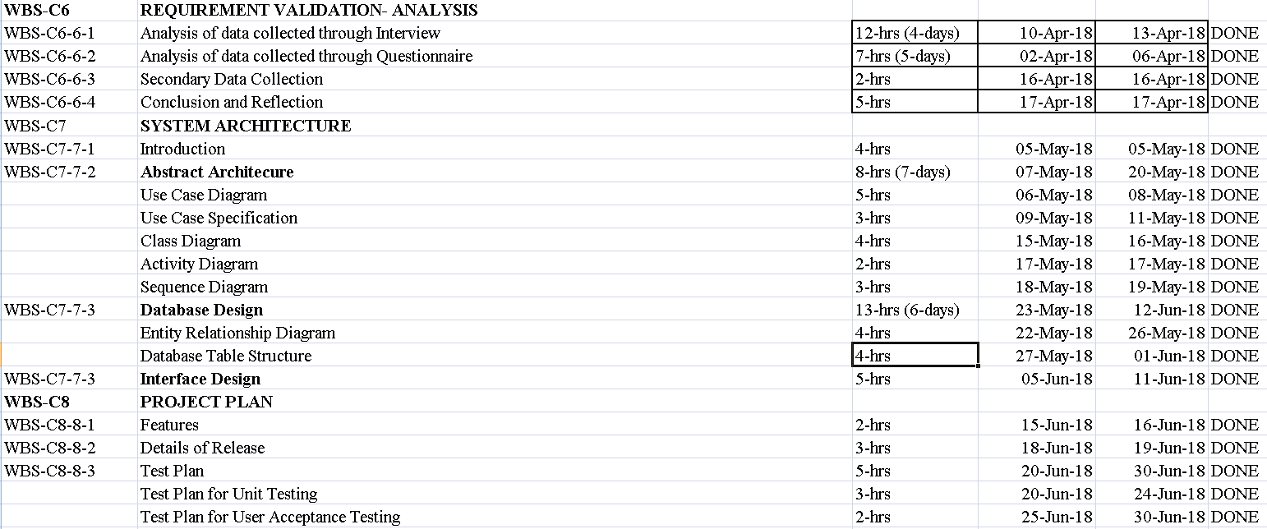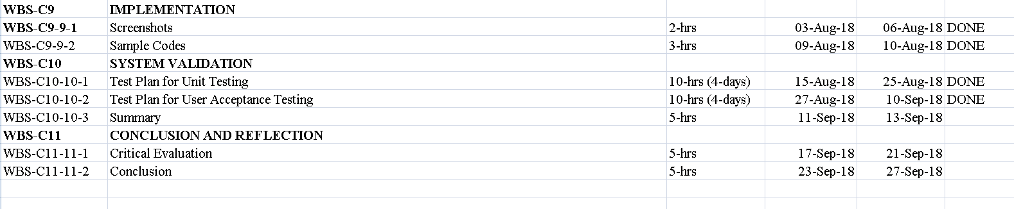

# 2. Literature review

### 2.1 Introduction

A literature review is an evaluative report of information found in the literature which is related to selected area of the study. The review describes summaries, evaluate and clarify the literature .It is based given in theoretical base for the research and help determine the nature of research .Works which are irrelevant should be discarded and those which are peripheral should be looked at critically. (rlf.org)

A literature review is more than the search of information and which have descriptive annotated bibliography. All works included in the review must be read, evaluated and analyzed. Relationships between the literatures must also be identified and articulated, in relation to field of research.

### 2.2 Domain Research

In computing and telecommunication in general, a domain is a sphere of knowledge identified by a name. Typically, the knowledge is a collection of facts about some program entities or a number of network points or addresses. (searchweb)The domain research carries out the bunch of studies based on numerous articles and different system previously built. The key benefits of conducting a domain research is that is allows the developer to know about the previous system developed system the current development though it informs about the conflict to be considered to solve in the current system.

As it is known the proposed project “LYRICS GRABBER”, is system that previously was developed by many developers as per their requirements, yet there were many conflicts occurred in the development as well as in the final production. However, it describes about the core purposes of the development of such system or application and let developer know-how about the core purpose of the current development.

## 2.3 Technical research

The type of research which is applied research oriented toward disciplines (but not to a specific product or process) and aimed at developing tools and test equipment and procedures, and at providing solutions to specific technical problems. (business)

It is conclusive with the chapter where the developer justifies the research report in terms of information gathering. The chapter is concluded by discussing the achievement obtained in Technical research is study of similar systems of proposed system. That developer has to understand aim and objectives and lead the project to its success. The research is to understand the, programming language, IDE and many other development tools. It helps in planning and development process. Here so I am going to discuss about the advantage and disadvantage of the projectof three similar systems. Lastly the research is finished with the help of the supervisor.

# 3. System Development Methodology

A System development method may be regarded as a path or a procedure by which the developer proceeds from a problem of a certain class to a solution of a certain class. In trivial cases, the method may be fully algorithmic; for example, there is an algorithmic procedure for obtaining the square root of a nonnegative number to any desired degree of accuracy. In more interesting cases, such as the development of computer-based systems for purposes such as data processing or process control, we do not expect to find an algorithmic method: the goal of the development is not precisely defined, and neither the problem nor the set of possible solutions is sufficiently well understood. But a method, to be worthy of the name, must at least decompose the development task into a number of reasonably well-defined steps which the developer can take with some confidence that they are leading to a satisfactory solution. (Jackson)

### 3.1 About Methodology

A system development methodology refers to the framework that is used to structure, plan, and control the process of developing an information system. A wide variety of such frameworks have evolved over the years, each with its own recognized strengths and weaknesses. One system development methodology is not necessarily suitable for use by all projects. Each of the available methodologies is best suited to specific kinds of projects, based on various technical, organizational, project and team considerations.

### 3.2 Selecting Methodology

There are many system development methodologies to choose for the project. Prototyping system development methodology will work best for the proposed project “Lyrics Grabber” because the requirements and functionality of the system can be added later.

## 3.3 Waterfall methodology

Waterfall methodology is a sequential design process. This means that as each of the eight stages conception, initiation, analysis, design, construction, testing, implementation, and maintenance are completed, the developers move on to the next step.

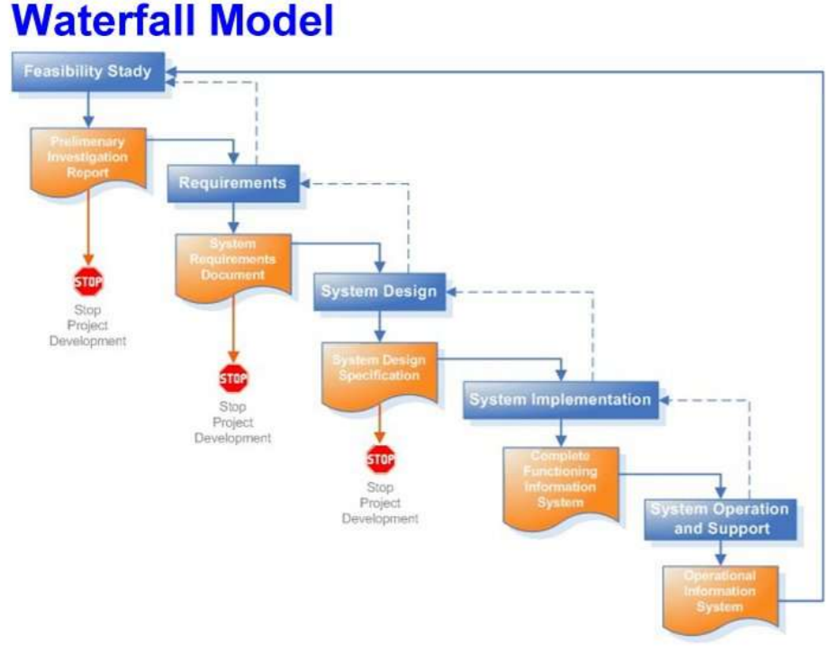

Figure 1: waterfall method

**Requirements**

At the beginning of a project you need to take several days to envision the high-level requirements and to understand the scope of the release. The goal here is to get a gut feel for what the project is all about. For the initial requirements model following things should be considered.

Usage model: As the name implies usage models enable you to explore how users will work with the system.

Initial domain model: A domain model identifies fundamental business entity types and the relationships between them. Domain models may be depicted as a collection of Class Responsibility Collaborator (CRC) cards, a slim UML class diagram, or even a slim data model.

User interface model: For user interface intensive projects one should consider developing some screen sketches or even a user interface prototype. This gives information about the outlook of the design and helps the developer and team to carry the work smoothly.

**Design**

Waterfall method is one of the most used methodologies and which is still a widely used way of working in software development companies. Some problem may face while using this methodologies. Commonly accepted problems are for example to cope with change and that defects all too often are detected too late in the software development process. The case study aims at validating or contradicting the beliefs of what the problems are in waterfall development through empirical research.The algorithm or flowchart of the program or the software code to be written in the next stage is created now. It is a very important stage, which relies on the previous two stages for its proper implementation. The proper design at this stage ensures an execution in the next stage. If during the design phase, it is noticed that there are some more requirements for designing the code, the analysis phase is revisited and the design phase is carried out according to the new set resources.

• Availability of the product

• Identified the product

Each iteration or sprint will also have its own plan.

**System Implementation**

Based on the algorithm or flowchart designed, the actual coding of the software is carried out. This is the stage where the idea and flowchart of the application is physically created or materialized. A proper execution of the previous stages ensures a smooth and easier implementation of this stage. Based on the algorithm or flowchart designed, the actual coding of the software is carried out.

**Acceptance**

This is the last stage of the software development in the waterfall model. A proper execution of all the preceding stages ensures an application as per the provided requirements and most importantly, it ensures a satisfied client. However, at this stage, you may need to provide the client with some support regarding the software, then the development process must begin anew, right from the first phase.

The waterfall model continues to remain one of the most commonly used methodologies. No doubt, new models have been used, but the widespread use of this model is the reason why it is studied in various software management subjects. With the above diagram, it will not have much difficult in understanding the process o f software development. This is the one of the simple software process models for application development.

Release planning is a collaborative effort involving these roles:

• Scrum master – Facilitates the meeting

• Product owner – Represents a general view of the product backlog

• Delivery team – Provide insights into technical feasibility and dependencies

• Stakeholders – Act as trusted advisors as decisions are made around the release plan

Materials Needed

• Posted purpose and agenda

• Organizing tools: Working agreements, parking lot, communication and logistics plan, issues and concerns, dependencies and assumptions, decisions.

• High tech: Projector, computer that can access needed data and tools, and a way for the computer to be shared

Planning Data

• Results of previous iterations and releases

• Feedback from stakeholders on the product, market situation, and deadlines

• Action plans and SMART goals from prior release and retrospective

• Items and defects to consider

• Development and architecture information

• Velocity from previous iterations or estimated

• Organizational and personal calendars

• Input from other teams and subject matter experts to manage dependencies

Output

• Release plan and commitment

• Issues, concerns, dependencies, and assumptions to be monitored

• Any new items for the release backlog

• Suggestions to improve future planning meetings.

### 3.2.1 Prototyping System Development Methodology

The Prototyping Model is a systems development method (SDM) in which a prototype(an early approximation of a final system or product) is built, tested, and then reworked as necessary until an acceptable prototype is finally achieved from which the complete system or product can now be developed. This model works best in scenarios where not all of the project requirements are known in detail ahead of time. It is an iterative, trial-and-error process that takes place between the developers and the users. (Naji, 2017)

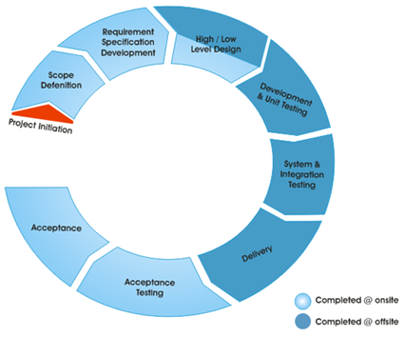

Figure 2:: Prototyping System Developing Methodology

**Steps in Prototyping a System**

* Identify as many requirements in as much detail as possible. This usually involves interviewing a number of users representing all the departments or aspects of the existing system.
* A preliminary design is created for the new system
* A first prototype of the new system is constructed from the preliminary design. This is usually a scaled-down system, and represents an approximation of the characteristics of the final product.
* The users thoroughly evaluate the first prototype, noting its strengths and weaknesses, what needs to be added, and what should to be removed. The developer collects and analyzes the remarks from the users.
* The first prototype is modified, based on the comments supplied by the users, and a second prototype of the new system is constructed.
* The second prototype is evaluated in the same manner as was the first prototype.
* The preceding steps are iterated as many times as necessary, until the users are satisfied that the prototype represents the final product desired.
* The final system is constructed, based on the final prototype.
* The final system is thoroughly evaluated and tested. Routine maintenance is carried out on a continuing basis to prevent large-scale failures and to minimize downtime

**Advantages**

Reduced time and costs: Prototyping can improve the quality of requirements and specifications provided to developers. Because changes cost exponentially more to implement as they are detected later in development, the early determination of what the user really wants can result in faster and less expensive software.

Improved and increased user involvement: Prototyping requires user involvement and allows them to see and interact with a prototype allowing them to provide better and more complete feedback and specifications. The presence of the prototype being examined by the user prevents many misunderstandings and miscommunications that occur when each side believe the other understands what they said. Since users know the problem domain better than anyone on the development team does, increased interaction can result in final product that has greater tangible and intangible quality. The final product is more likely to satisfy the user’s desire for look, feel and performance.

**Disadvantages**

Excessive development time of the prototype: A key property to prototyping is the fact that it is supposed to be done quickly. If the developers lose sight of this fact, they very well may try to develop a prototype that is too complex. When the prototype is thrown away the precisely developed requirements that it provides may not yield a sufficient increase in productivity to make up for the time spent developing the prototype. Users can become stuck in debates over details of the prototype, holding up the development team and delaying the final product.

Expense of implementing prototyping: the start up costs for building a development team focused on prototyping may be high. Many companies have development methodologies in place, and changing them can mean retraining, retooling, or both. Many companies tend to just jump into the prototyping without bothering to retrain their workers as much as they should.

### 3.2.2 Phases of Prototyping System Development Methodology

**Initial Requirements**

Get lists of some major requirements which define the need for the new system including the main input output.

**Design**

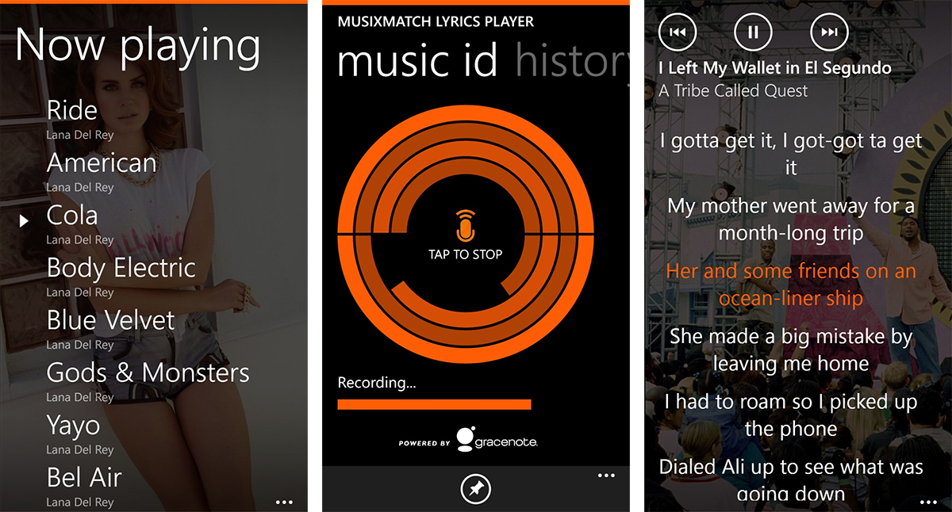

Figure 3: design

In this phase the system and software design is prepared from the requirement specifications which were studied in the first phase. System Design helps in specifying hardware and system requirements and also helps in defining overall system architecture. The system design specifications serve as input for the next phase of the model.

**Prototyping**

Develop a basic initial prototype which only has UI screens.

**Customer Evaluation**

End users examine the prototype and provide feedback for improvements/ enhancements.

**Review and updating**

Scope is changed based on feedback from end users and the prototype is enhanced and refined to accommodate user feedback.

**Development**

Once the user is satisfied with the developed prototype, a final system is developed on the basis of the final prototype.

**Test**

After the code is developed it is tested against the requirements to make sure that the product is actually solving the needs addressed and gathered during the requirements phase. During this phase all types of functional testing like unit testing, integration testing, system testing, acceptance testing are done as well as non-functional testing are also done.

**Maintain**

Once when the customers starts using the developed system then the actual problems comes up and needs to be solved from time to time. This process where the care is taken for the developed product is known as maintenance.

### 3.2.3 Situation where Prototyping is most suitable

Prototype model should be used when the desired system needs to have a lot of interaction with the end users. Typically, online systems, web interfaces have a very high amount of interaction with end users, are best suited for Prototype model. It might take a while for a system to be built that allows ease of use and needs minimal training for the end user. Prototyping ensures that the end users constantly work with the system and provide a feedback which is incorporated in the prototype to result in a useable system. They are excellent for designing good human computer interface systems.

### 3.2.4 Justification

This design methodology is sometimes known as evolutionary design or incremental development. Different versions of prototyping are used in software design, system development, and electronics engineering. What better way to determine if the concept is in conjunction with your business expectations. And only then can make the refinements needed to develop final product/solution.

A prototyping methodology is a software development process which Prototyping Methodology allows developers to create portions of the solution to demonstrate functionality and make needed refinements before developing the final solution. This methodology works very well with online transaction processing systems, which usually interact. It also works well with web-based development and can very quickly help confirm page navigation and other user interaction requirements.

# 4. Development and Deployment

On receiving system design documents, the work is divided in modules/units and actual coding is started. Since, in this phase the code is produced so it is the main focus for the developer. This is the longest phase of the software development life cycle. After successful testing the product is delivered / deployed to the customer for their use. As soon as the product is given to the customers they will first do the testing. If any changes are required or if any bugs are caught, then they will report it to the developing team. Once those changes are made or the bugs are fixed then the final deployment will happen.

The system with good planning always carries out a good quality on its deliverable to facilitate its end users. Since, the proposed project is at its early stage of development, the planning takes place to provide a better image of the system where all the necessary information is gathered based on the previous research and the requirement of the proposed project.

## 4.1 Programming Language Chosen

A programming language is a special language programmers use to develop software programs, scripts, or other sets of instructions for computers to execute. Over the evolution of computers, there have been hundreds of different computer programming languages created for various types of development. The most suitable programming language to be used in the development of the proposed project is “java”. Explanations of chosen programming languages for better understanding are as follow. (journaldev)

**Java**



Figure 4: JAVA

Java was designed to have the look and feel of the C++ language, but it is simpler to use than C++ and enforces an object-oriented programming model. Java can be used to create complete applications that may run on a single computer or be distributed among servers and clients in a network. It can also be used to build a small application module or applet for use as part of a webpage. Programs created in Java offer portability in a network. The source code is compiled into what Java calls byte code, which can be run anywhere in a network on a server or client that has a Java virtual machine (JVM). The JVM interprets the byte code into code that will run on computer hardware. In contrast, most programming languages, such as COBOL, C++, Visual Basic or Smalltalk, compile code into a binary file. Binary files are platform-specific, so a program written for an Intel-based Windows machine cannot on run a Mac, a Linux-based machine or an IBM mainframe. The JVM includes an optional just-in-time (JIT) compiler that dynamically compiles byte code into executable code as an alternative to interpreting one byte code instruction at a time. In many cases, the dynamic JIT compilation is faster than the virtual machine interpretation. (devjava)

**NETBEANS**



Figure 5: NetBeans

NetBeans is an open-source integrated development environment (IDE) for developing with Java, PHP, C++, and other programming languages. NetBeans is also referred to as a platform of modular components used for developing Java desktop applications.

**Python**

Python is simple and incredibly readable since it closely resembles the English language. It’s a great language for beginners, all the way up to seasoned professionals. Python recently bumped Java as the language of choice in introductory programming courses with eight of the top 10 computer science departments now using Python to teach coding, as well as 27 of the top 39 schools. Because of Python’s use in the educational realm, there are a lot of libraries created for Python related to mathematics, physics and natural processing. PBS, NASA and Reddit use Python for their websites. The python is increasing its popularity due to the easiness in using the language as a beginner. The language is famous for building the desktop application and the web application. (tutorialspoint, 2018)

**PHP (Hypertext Pre-Processor)**

PHP (Hypertext Pre-Processor) is a scripting language, running on the server, which can be used to create web pages written in HTML. PHP tends to be a popular language since its easy-to use by new programmers, but also offers tons of advanced features for more experienced programmers. Todays, more than 80% of the internet is powered by the PHP. This means the PHP is still the best language for the web development purposes. The purpose of the PHP is only concentrated with the web development thus they are providing the valuable system to deal with. (php, 2018)

The outputs of the project are the web application and the android application. On the basis of the study done and the research made the choice of the programming language has been done. As per the statistics and the user preference PHP seems to the best language to start the web development with HTML and CSS in front end.

**Mobile Application (Android)**

The mobile application is the priority product to be delivered as per the present market demand. The android based mobile application is supposed to fulfill the present requirements of the project. Java is to be used for the development of the beautiful and powerful mobile application with the addition of the many required features.

## 4.2 IDE (Interactive Development Environment) chosen

An integrated development environment (IDE) is a software suite that consolidates the basic tools developers need to write and test software. Typically, an IDE contains a code editor, a compiler or interpreter and a debugger that the developer accesses through a single graphical user interface (GUI). An IDE may be a standalone application, or it may be included as part of one or more existing and compatible applications.

The most famous IDE currently in use are as follows.

**Sublime text editor**

Sublime Text is a versatile editor for programmers and it don’t requires the professional need to be one in order to use it, and one don’t need to configure it extensively to be productive—it’s an efficient tool out of the box. Sublime is the simple IDE famous among the developer for the web development. The simple and extensive features of the sublime make it a complete system to make a full development and implementation of the web application. The features of sublime are listed below:

• Auto completion, Syntax Highlight, Code Folding

• Customizability

• Lightweight, Fast and Stable

• Powerful Search

• Simultaneous Editing

• Cross-platform(elegantthemes, 2018)

**Eclipse**

In the context of computing, Eclipse is an integrated development environment (IDE) for developing applications using the Java programming language and other programming languages such as Java, C/C++, Python, PERL, Ruby etc.

The Java Development Tools (JDT) project provides a plug-in that allows Eclipse to be used as a Java IDE, PyDev is a plugin that allows Eclipse to be used as a Python IDE, C/C++ Development Tools (CDT) is a plug-in that allow’s Eclipse to be used for developing application using C/C++, the Eclipse Scala plug-in allows Eclipse to be used an IDE to develop Scala applications and PHPeclipse is a plug-in to eclipse that provides complete development tool for PHP.(tutorialspoint, n.d.)

The eclipse is also quite famous for the development of the android application. It provides the large extent of libraries to work with. It is thus can be one of the leading IDE for the application development of different kinds.

**Android Studio**

Android Studio is the official Integrated Development Environment (IDE) for Android app development, based on IntelliJ IDEA . On top of the powerful code editor and developer tools, Android Studio offers even more features that enhance your productivity when building Android apps, such as:

• A flexible Gradle-based build system

• A fast and feature-rich emulator

• A unified environment where you can develop for all Android devices

• Instant Run to push changes to your running app without building a new APK

• Code templates and GitHub integration to help you build common app features and import sample code

• Extensive testing tools and frameworks

• Lint tools to catch performance, usability, version compatibility, and other problems

• C++ and NDK support

• Built-in support for Google Cloud Platform, making it easy to integrate Google Cloud Messaging and App Engine(android, 2018)

The android studio is particularly for the development of the android application. The android studio provides large extend of the libraries and the plugins for the development of the android application making it utmost in the field of android development.

**Choice of the IDE**

Thus, on the basis of the study done on the different IDEs and its usefulness the conclusion has been made on the choice of the appropriate IDE. There are numerous IDE available for the development of the web application and the android application.. The sublime is simple and interactive tools that can be used for the development of the web application.

Similarly, Android studio is used for the development of the android application. This is the powerful IDE with the update made on the regular basis which provides the user-friendly environment to work on with. The android most widely used IDE for the development of the android-based application. The advanced regular update of the android studio helps on creating a powerful application in the short period of time.

## 4.3 Libraries chosen / Tools chosen

Libraries are basically the collection of the classes, interfaces and the other essential functionalities. The java makes the use of the wide range of libraries and its functionalities. Libraries are the inner built in function that makes the easier working environment development tools. The tools and the libraries may be increased or decreased based upon the developing environment and the project criteria.

## 4.4 Operating System chosen

An operating system (OS) is the program that, after being initially loaded into the computer by a boot program, manages all the other programs in a computer. The other programs are called applications or application programs. The application programs make use of the operating system by making requests for services through a defined application program interface (API). In addition, users can interact directly with the operating system through a user interface such as a command line or a graphical user interface (GUI).(techtarge, 2018)

The different operating system and their usability are discussed below

**Windows 7**

Microsoft has worked under the code name Windows 7 on the successor of Windows Vista since approximately August 2007. The operating system is based on Windows Vista and comes with new program functions and improvements in detail. Since then windows 7 became the most widely used Operating system ever. The good user-friendly behavior of the windows 7 and the easy platform for the development works puts windows 7 as the best model of the OS. The OS was quite famous for the development and the deployment works unless the release of more complete and efficient OS i.e. Windows 10.(operating-system, 2018)

Windows 7 system requirements

• 1 gigahertz (GHz) or faster 32-bit (x86) or 64-bit (x64) processor*

• 1 gigabyte (GB) RAM (32-bit) or 2 GB RAM (64-bit)

• 16 GB available hard disk space (32-bit) or 20 GB (64-bit)

• DirectX 9 graphics device with WDDM 1.0 or higher driver

**Windows 10**

Windows 10 is a Microsoft operating system for personal computers, tablets, embedded devices and internet of things devices.Microsoft released Windows 10 in July 2015 as a follow-up to Windows 8. The company has said it will update Windows 10 in perpetuity rather than release a new, full-fledged operating system as a successor.

Windows 10 features built-in capabilities that allow corporate IT departments to use mobile device management (MDM) software to secure and control devices running the operating system. In addition, organizations can use traditional desktop management software such as Microsoft System Center Configuration Manager.(searchenterprisedesktop, 2018)

Windows 10 hardware system requirements

• Processor: 1 gigahertz (GHz) or faster processor or system-on-a-chip (SoC)

• RAM: 1 gigabyte (GB) for 32-bit or 2 GB for 64-bit

• Hard disk space: 16 GB for 32-bit OS 20 GB for 64-bit OS

• Graphics card: DirectX 9 or later with Windows Display Driver Model 1.0

• Display: 800x600(techtarget, 2018)

**Linux**

Linux is the best-known and most-used open source operating system. As an operating system, Linux is software that sits underneath all of the other software on a computer, receiving requests from those programs and relaying these requests to the computer’s hardware. Linux is also different in that, although the core pieces of the Linux operating system are generally common, there are many distributions of Linux, which include different software options. This means that Linux is incredibly customizable, because not just applications, such as word processors and web browsers, can be swapped out. Linux users also can choose core components, such as which system displays graphics, and other user-interface components. Linux is particularly difficult to use for the new user who are using other operating system like windows 7, windows 10 etc.(opensource, 2018)

Recommended Minimum System Requirements

• 2 GHz dual core processor.

• 2 GB RAM (system memory)

• 25 GB of hard-drive space (or USB stick, memory card or external drive but see Live CD for an alternative approach)

• VGA capable of 1024x768 screen resolution.

• Either a CD/DVD drive or a USB port for the installer media(ubuntu, 2018)

**Choice of the OS**

On the research and study made Windows 10 was felt to be the best choice among the OS for the development of the current system.Windows 10 is the most powerful and the secured operating system ever built by Microsoft. The fast and the multi-processing behavior makes windows 10 as the best to be used for the development of the preferred application. The brilliant working environment of the windows 10 makes it super-efficient to carry out the developmental activities. The requirements of the android studio are very high and thus the use of windows 10 is more beneficial to carry out the developmental activities.

## 4.5 Conclusion

Hence the system will be developed using above programming language, development platform, Android Studio, JAVA, operating system, and many other tools. In the future there might be change in version and functions of the above mentioned tools as technology is regularly keep upgrading. So, proposed system “LYRICS GRABBER” might also use upgraded version of different tools in development phase.

# 5. Primary Research

## 5.1 Background Introduction

Research is a careful and detailed study into a specific problem concern, or issue using the scientific method. It's the adult form of the science fair projects back in elementary school, where you try and learn something by performing an experiment. This is best accomplished by turning the issue into a question, with the intent of the research to answer the question.

For example, engineers, who focus on applying scientific knowledge to develop designs, processes, and objects, conduct research using simulations, mathematical models, and a variety of tests to see how well their designs work. Sociologists conduct research using surveys, interviews, observations, and statistical analysis to better understand people, societies, and cultures. Graphic designers conduct research through locating images for reference for their artwork and engaging in background research on clients and companies to best serve their needs. Historians conduct research by examining archival materials—newspapers, journals, letters, and other surviving texts—and through conducting oral history interviews. Research is not limited to what has already been written or found at the library, also known as secondary.

There are two types of research primary and secondary research. Primary research is research you conduct yourself (or hire someone to do for you.) It involves going directly to a source —usually customers and prospective customers in your target market — to ask questions and gather information. Examples of primary research are:

* Interviews (telephone or face-to-face)
* Surveys (online or mail)
* Questionnaires (online or mail)
* Focus groups
* Visits to competitors' locations

Secondary research is a type of research has already been compiled, gathered, organized and published by others. It includes reports and studies by government agencies, trade associations or other businesses in your industry. Especially for small businesses with limited budgets, most research is typically secondary, because it can be obtained faster and more affordable than primary research. A lot of secondary research is available right on the Web, simply by entering key words and phrases for the type of information you’re looking for. You can also obtain secondary research by reading articles in magazines, trade journals and industry publications, by visiting a reference library, and by contacting industry associations or trade organizations.

## 5.2 Importance of primary research and factors affecting the proposed system

### 5.2.1 Importance of primary research

**Accuracy**

The measure of how accurately studies really represent a group, community, people or a person it claims to represent is called representativeness. Researchers make attempts to determine each study’s representatives which they conduct themselves.

They also check the studies of other researchers to back their claims. When researchers use primary data, they observe data in real time and are at the scene where collection of data is going on. Therefore, researchers can be certain that the recorded data is a reflection of reality.

On other words, primary research is the closes form of information to the idea or the topic being studied. Information is a genuine, first-hand account that has not been altered by other scholars. Unaltered, genuine information is more reliable particular for subjects such as history.

**Depth**

In a sociological study, it is impossible to get the appropriate and necessary depth of a study when reporting on the level of a small group or individual when you use only secondary data. Directly recording observations, feelings, thoughts and words from primary data is a kind of depth that really solidifies studies to which general readers able to relate.

**Contrast/Compare**

As a comparison to secondary data, primary data comes in quite useful. When a researcher finds primary data, sociologists can see how data measures up to studies those other researchers have done on the same subject. If the information does not match, there needs to be a justification of new findings which might result in new information that discredits a previous belief.

**Bias**

Most research studies set out to explore a hypothesis’ possibilities or to answer a question. When researchers do their own study, they can be aware of what bias is brought to the writing of that study and to research. Here is a market research course that puts you on a fast track to finding out exactly what customers want.

**Control**

When researchers use primary data, there is maximum control about the method of collecting the data itself including for what purpose it is going to be used for, whom it is collected by and who it is collected from. Primary research follows the scientific method, which involves forming a hypothesis and based on this, collecting data from experiments to prove whether or not the hypothesis is right or wrong.

Also, when students work with primary research, this helps them understand scholarship’s methodology. For example, replicating a scientific experiment’s results allows students to grasp exactly how important the basic philosophy of science is in general as well as the scientific method.

**Appreciating Potential**

When engaging in primary research, working with the data and the texts themselves without ‘expert mediation’ gives students a significant sense of mastery and competence that may even lead to new advanced research career paths. It could even escalate to something very profitable, the way this market research course explains it.

**You Get A Direct Experience**

When students engage in primary research, they get to experience information in a direct, personal manner. In the subject of history, for instance, reading a period memoir written by someone of the same age will give students a first person, powerful look at events that happened in history.

**You Become an Active Participant**

One essential part of the process of learning is engaging students in primary research. This transforms researchers/students from passive information recipients to active participants in the process of knowledge-building. Students are allowed to experience the material vividly when working with primary sources and doing experiments. Dry renderings of a textbook’s conclusion just cannot replace what primary research can offer.

## 5.3 Selected data gathering methods for proposed project

Scientific norms and rules govern how to collect data. Text books and professional guides detail how each of these techniques should be used. The respective strengths and weaknesses of each technique selected must be understood and recognized.

**Case Study**

The case study technique involves focusing on a particular individual, organization or group, such as a corporation, non-profit agency or religious cult, to name a few. The goal of a case study is limited to descriptively detailing how a particular case operates or develops within the specific parameters of the environment. A number of techniques are typically used to collect the data/information, ranging from available data and information to interviews with key stakeholders or informal field studies involving attendance at events, ceremonies or meetings.

**Document Analysis**

This involves interpreting documents such as court rulings or letters in order to gain insight into the thought processes or ideas surrounding a particular issue, person or event. The “reading” of the document involves a series of critical questions such as the purpose, audience, authenticity and significance of the author and the document. Code sheets for categorizing the data derived from a careful “reading” are sometimes designed for this technique. It is used mainly by historians using primary sources and is often used in conjunction with other data collection techniques.

Though this is called a type of analysis, which it is to a certain extent, it is categorized as a method or technique. It is difficult to separate the technique of obtaining the data from the actual process of analyzing it.

**Survey**

Surveys are any form of questioning of a sample of people with hopes of getting an insight into a larger population of people. Since people are either being asked to fill out a questionnaire, or are being asked by a door-to-door interviewer or by someone on the telephone, or responding to questions from a computer, surveys usually depend on self-reporting of the data by the subject. In the past door-to-door or phone interviewers were often instructed to fill out some information by observation, such as age, gender or "race", or impressions of the subject while responding, facial responses such as looking down or into the eyes of the interviewer? Trained interviewers also can easily follow a branching survey. With today's phone-robot and online surveys there is very little door-to-door surveying done and the phone robots cannot usually discern gender or speaking accent. However, computers and phone robot interviewers can time responses and note changes to answers, and phone robots could (I do not know whether they do) register rising tone answers. And computerized surveys can easily be programmed to branch depending on the previous answers.

# 6. Requirement validation

Data analysis is a primary component of data mining and Business Intelligence (BI) and is key to gaining the insight that drives business decisions. Organizations and enterprises analyze data from a multitude of sources using Big Data management solutions and customer experience management solutions that utilize data analysis to transform data into actionable insights.

## 6.1Questioner data analysis

For research paper questionnaire are used, someone will need to manually transfer the responses from the questionnaires into a spreadsheet. Put each question number as a column heading, and use one row for each person’s answers. Then assign each possible answer a number or ‘code’.

Go through each respondent’s questionnaire in turn, adding in the codes. Enter this data into a spreadsheet. Once the researcher has entered the data from all the questionnaires into a spreadsheet, it is a good idea for someone else to check some of the data for accuracy. If there are many errors, consider checking more of the data.

When the group is happy that all the data is present and correct, calculate how many people selected each response. The researchers could count this up manually, but it is easier to let the spreadsheet do the work, by adding a filter to each question within the spreadsheet. Once the researcher has calculated how many people selected each response, the young researchers can set up tables and/or graph to display the data.

These are the number of questions to be asked to the users or clients of Lyrics Grabber.

Marital Status: Age:

Gender:

Occupation:

**Random** **people**

1. How do you find lyrics of song??

* Easy
* Difficult
* Very difficult

1. There is app named musicXmatch have you ever used it?

* Used several times(good)
* Never heard
* Used (Not reliable)
* N/A

1. Are you fond of music?

* Yes
* Satisfactory
* No
* N/A

1. Do you love music?

* Yes
* Satisfactory
* No
* N/A

1. How useful do you find to use musicxmatch?

* Good
* Satisfactory
* Not useful
* Never heard

1. Would you be interested in using this kind of app?

* Interested
* Not interested
* N/A

1. How do you rate this kind of app will be useful?

* Excellent
* Satisfactory
* Poor
* N/A

1. Will it be useful or fun to you?

* Yes
* No
* N/A

**Questionnaires for Musician/artist**

1. How do you find lyrics of a particular song?

* Difficult
* Take help of internet
* No answer

1. Is it hard?

* Yes
* Satisfactory
* No
* N/A

1. Have you ever thought of using an app which can generate lyrics of songs?

* Sometimes
* No
* Used few times, not useful
* N/A

1. Would you be interested in using this kind of app?

* Interested
* Not interested
* N/A

1. How do you manage your playlist?

* properly
* mix max
* N/A

1. Can you find lyrics of all generic music ?

* Yes
* No
* Don’t know
* N/A

1. Will itS be helpful to you?

* Yes
* No
* N/A

1. Have you ever find hard to get lyrics of songs?

* Yes
* No
* Sometimes
* N/A

1. Did finding lyrics of song is time consuming or not?

* Yes
* No
* Sometimes

1. Will lyrics grabber be able to exist in the current market?

* Yes
* No
* Don’t know
* N/A

1. Will this app will be helpful or not?

* Yes
* Frequently
* No
* N/A
* N/A

How do you find searching lyrics of song??

|  |
| --- |
| Analysis: This analysis shows the portion of how to get lyrics how they find the lyrics of a particular songs. |

There is app named musicXmatch have you ever used it?

|  |
| --- |
| Analysis: This section shows the where people have used similar apps where the chart shows that many of them never heard and app which can generate lyrics. |

Do you love music?

|  |
| --- |
| Analysis: This question was asked to all the random people as well as musican which answer are shown in the chart. |

Are you fond of music?

|  |
| --- |
| Analysis: Based on the question above, it is illustrated in the chart that majority respondents, whereas people love music or not. |

How useful do you find to use MusicXmatch?

|  |
| --- |
| Analysis: Based on the question above, it is illustrated in the chart that majority of people using and app named MusicXmatch. |

Would you be interested in this app?

|  |
| --- |
| Analysis: The chart shows the how many people whom the questionnaire is done are interested or not in app like this. |

How would you rate this kind of app??

|  |
| --- |
| Analysis: Above chart shows the how would and individual rate this app. |

Will it be useful to you?

|  |
| --- |
| Analysis: Here the chart shows how many would it find useful. |

ss

How do you find lyrics of a particular song?

|  |
| --- |
| Analysis: This part shows how people have time getting the lyrics of song. |

Is it hard?

|  |
| --- |
| Analysis: Based on question how hard to get the lyrics of the particular song is shown in the chart. By the musician artist as well as random people. |

Have you ever thought of using an app which can generate lyrics of songs?

|  |
| --- |
| Analysis: This section shows that ever people have thought using app which can generate the lyrics of a song and it is shown in chart. |

How do you manage your playlist?

|  |
| --- |
| Analysis: The graph shows the how a particular person manages their playlist. |

Can you get lyrics of all generic?

|  |
| --- |
| Analysis: From the above question it shows if an individual can get lyrics of the song according to generic. |

Will it be helpful to you?

|  |
| --- |
| Analysis: This question was asked to most the artist who are taking their occupation as musician and the result is shown in graph. |

Have you ever find hard to get lyrics of songs?

|  |
| --- |
| Analysis: Above chart shows how an individual to get hard to find lyrics of song. |

Did finding lyrics of song is time consuming or not?

|  |
| --- |
| Analysis: Based on questionnaire this graph shows if getting a lyrics of song is time consuming or not. |

This conducted was a great stage of the research which gave some encouragement for the development of the app.S

# Chapter 7: System Architecture

## 7.1 Introduction

The main focus of the project is to get the lyrics of the songs. After that, it also allows the user to get the lyrics of the song. Android Studio is chosen for the development of this project. Therefore, Android Studio that is used to make this system. This will help people to get the lyrics of the song.

After that, Lyrics Grabber is and mobile application – based system and this system is going to be used by people who are fond of lyrics. As the assignments, marks and feedbacks are keep increasing for the student which will help them to developed further more. So the mobile designs have to be accurate to work in all devices.

Without the core aspects, which are mentioned at the above, the researcher would not come out with a system that has the high quality. Therefore, the aims and objectives would not be achieved, which means the project would be the fail project.

# 7.2 Abstract Architecture

## 7.2.1 System Design

### 7.2.1.1 Use Case Diagram

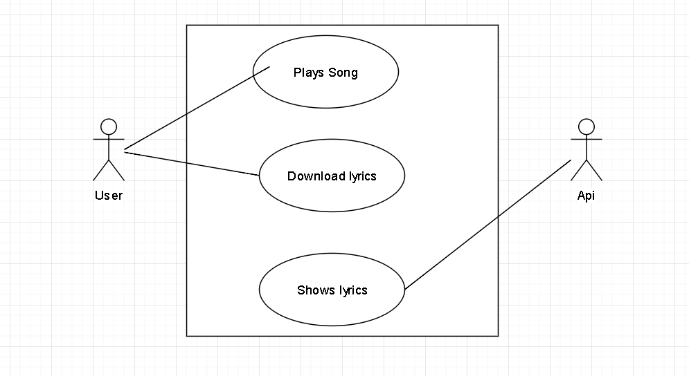

Figure 6 : Use case Diagram of Lyrics Grabber

The Figure above shows about the use case diagram of the Lyrics grabber. With the presence of the users, which are the people, the system from where lyrics is grabbed and where the system able to perform the objectives.

### 7.2.1.2 Use Case Specification

**Plays song**

|  |  |
| --- | --- |
| User | All People |
| Priority | Medium |
| Description | This is where a user opens the music player and plays the song |
| Extends | None |
| Includes | All generic music |
| Pre condition | User must be using android device |
| Post condition | Users are able to use the system as they want as related to music and lyrics |
| Flow of events | * Opens the device * Open music player * Plays a song |

Table 1: Use case

This is where the users have to first open the music player to play the song. Post-condition the users are able to use the system based on the function which are provided to them Flow of Events.

**Download Lyrics**

|  |  |
| --- | --- |
| User | All People |
| Priority | Medium |
| Description | This is where user runs the application Lyrics Grabber |
| Extends | None |
| Includes | * All generic music. * Have to play a song. |
| Pre condition | * User must be using android device * They must be connected to Internet * The lyrics must have to be in Internet |
| Post condition | None |
| Flow of events | * Opens the Application * Press on download button * Download the lyrics |

Table 2: Download specification

Here is the thing after the user opens the application and how the lyrics can be got. Pre-condition the users are able to use the system based on the function which are provided to them Flow of Events.

**Shows Lyrics**

|  |  |
| --- | --- |
| User | All People |
| Priority | Medium |
| Description | This is where user runs the application Lyrics Grabber and as well as plays a song in music player |
| Extends | None |
| Includes | * All generic music * Have to play a song |
| Pre condition | * User must be using android device * They must be connected to Internet * The lyrics must have to be in Internet |
| Post condition | None |
| Flow of events | * Opens the Application * Press on download button * Download the lyrics * Choose a song * Scroll the top bar * Click on the lyrics grabber icon * Lyrics will automatically pop up |

Table 3: Shows lyrics

Hence the application is run with the flow of events with according pre and post condition which are listed in above and shows the lyrics of the song.

### 7.2.1.3 Class Diagram

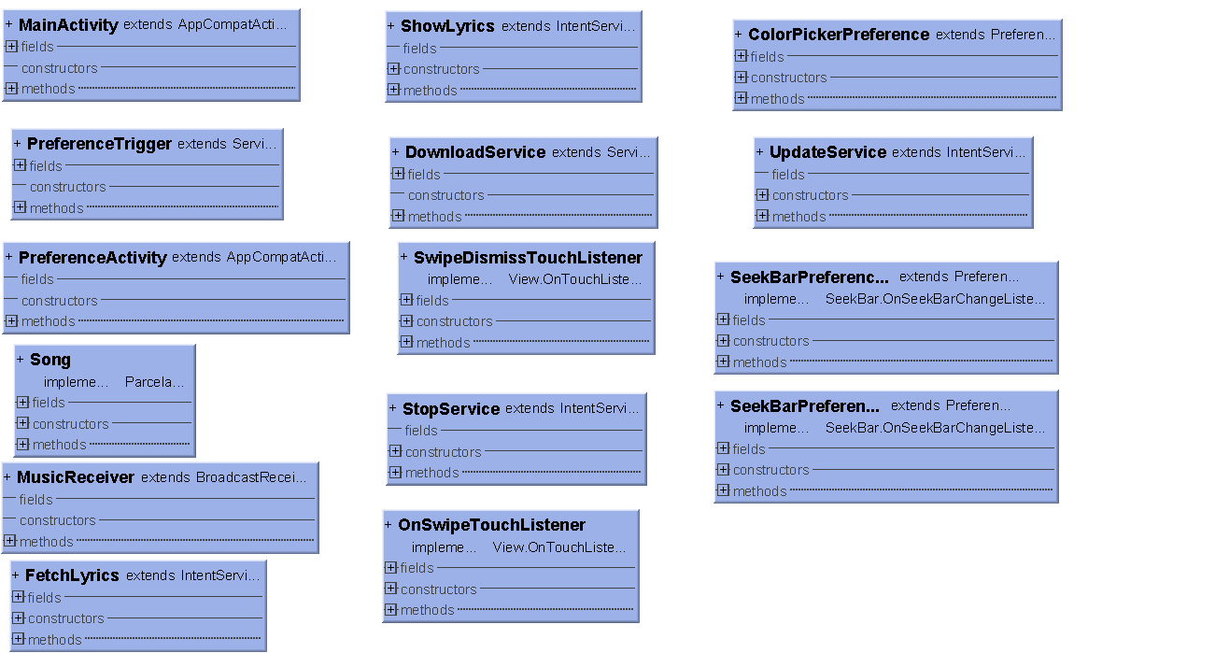

Figure 7: Class Diagram of Lyrics Grabber

A class diagram is an illustration of the relationships and source code dependencies among classes in the Unified Modeling Language (UML). The Figure above shows about the class diagram of the Lyrics Grabber. The class diagram structure consists. The most of the classes can be accessed by the user like main activity class, update service class , Seek bar preference class, song class but some classes like fetch lyrics , preference trigger cannot be accessed by the user where as it can only accessed by the system. To fetch the lyric system has to be run by the user which means in order for the system to give lyrics the user has to run the application.

### 7.2.1.4 Activity Diagram

**Plays Song**

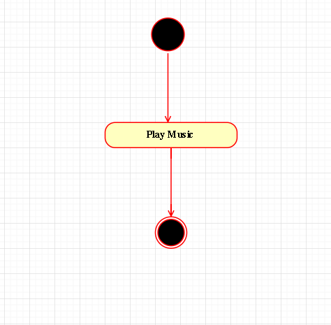

Figure 8: activity diagram of play song

**Download lyrics**

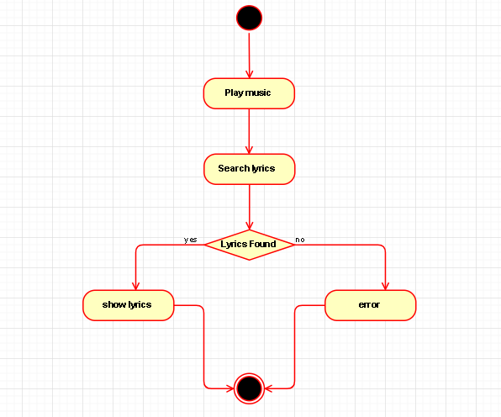

Figure 9: activity diagram of download song

**Shows Lyrics**

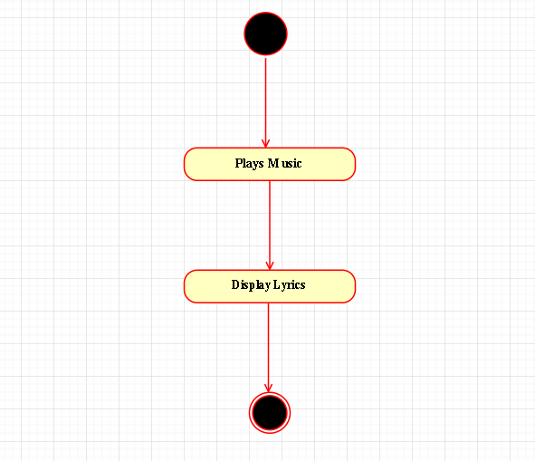

Figure 10: activity diagram of shows lyrics

### 7.2.1.5 Sequence Diagram

**Plays Song**

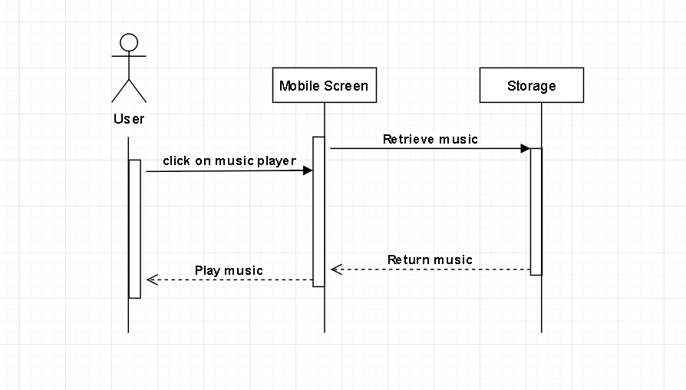

Figure 11: sequence diagram of play song

**Download Lyrics**

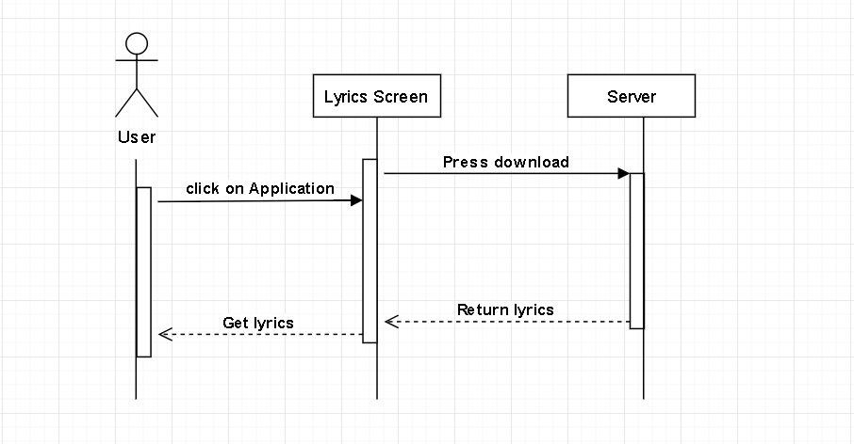

Figure 12: sequence diagram of download lyrics

**Shows lyrics**

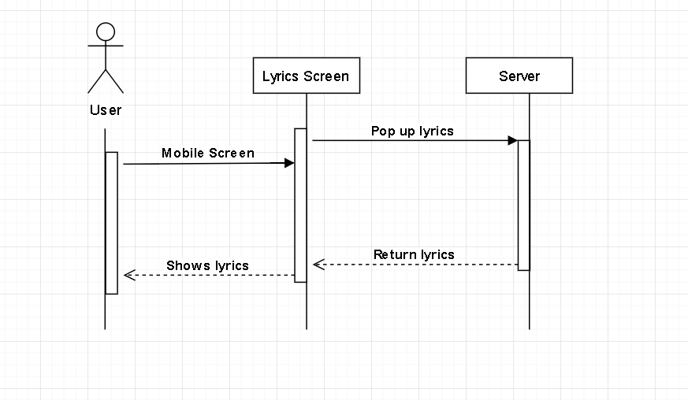

Figure 13: sequence diagram of show lyrics

## 7.2.3 Interface Design

**Start up**

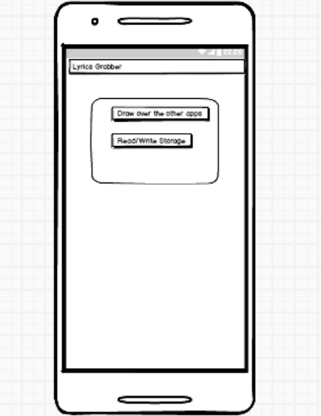

Figure 14: interface of start up

The Figure above shows the start up after the installation of the application.

**Installation**

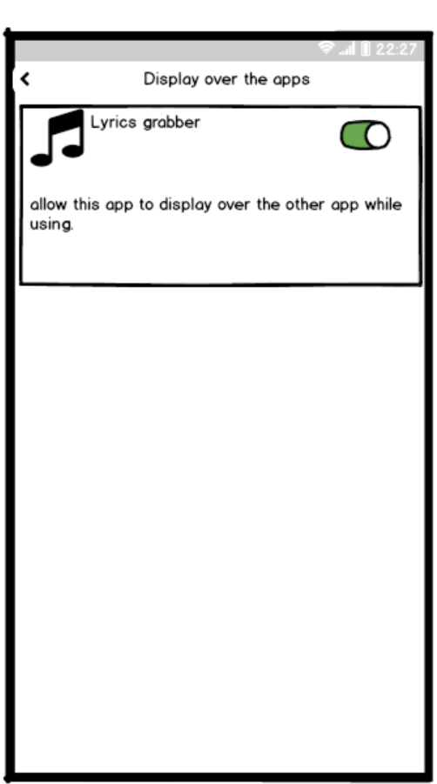

Figure 15: interface of installation

The Figure above shows about the option after the start-up. This is where the user have to allow the application to display over the other apps so the lyrics can be generate when there is another app.

**Home**

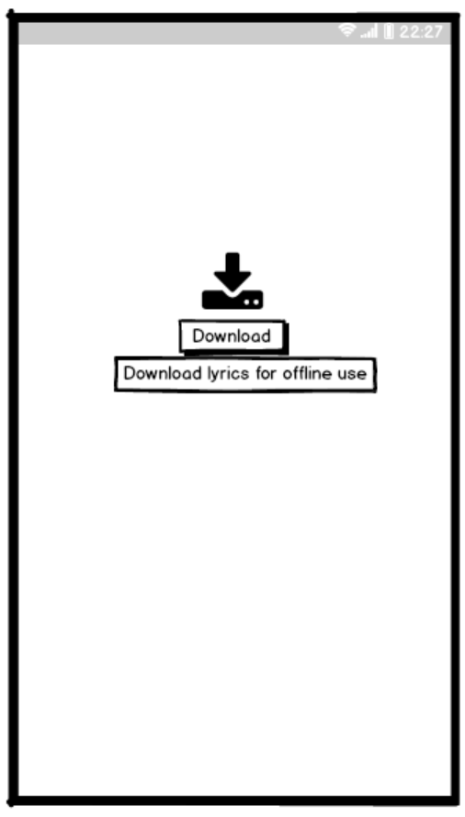

Figure 16: interface of downloading lyrics

The Figure above shows about is the front display of the application by pressing the download button you can download the lyrics of the song.

**Download Lyrics**

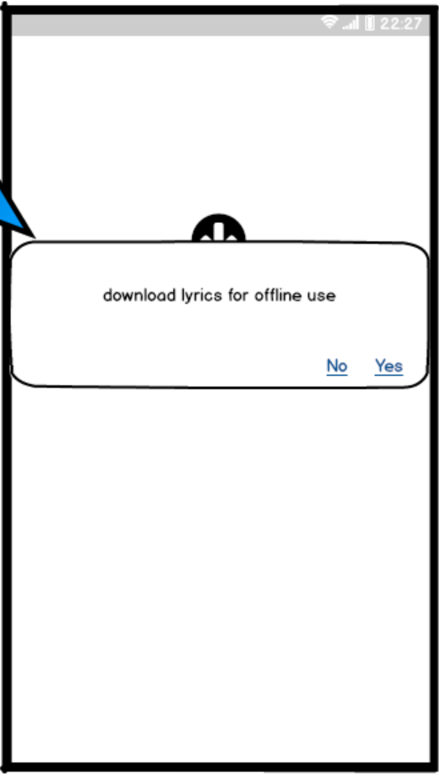

Figure 17: interface of downloading

The Figure above shows about the download option. This is where the users have to press the download button and a box shows to weather download lyrics of the song. After that, the users just have to press the yes then the download starts.

**Downloading**

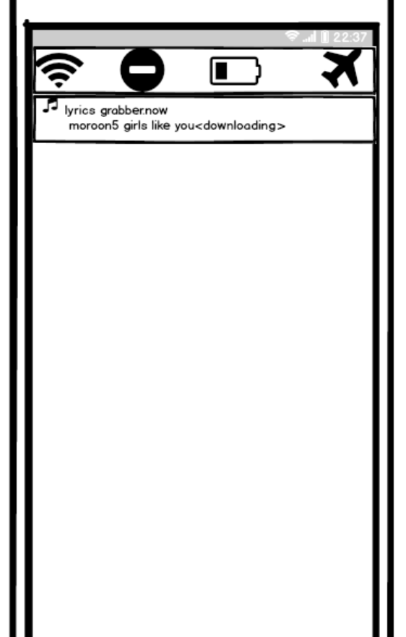

Figure 18: interface of lyrics downloading

The Figure above shows that application is going to download lyrics of the song. The user has to scroll down the top bar to see whether the lyric is downloading or not. After that, the users just have to press the lyrics grabber icon to view lyric.

**Shows Lyrics**

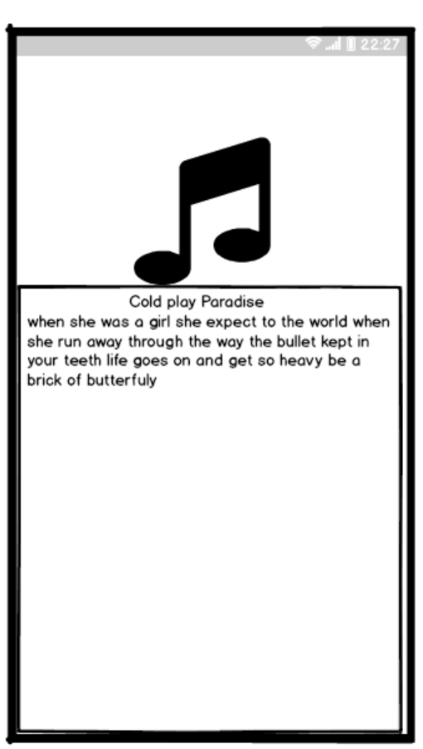

Figure 19: interface design of shows lyrics

The Figure above shows about the lyric popping up in the screen. This is where the user gets the lyrics of the song with the help of internet when the lyrics grabber button is clicked

# Chapter 8: Project Plan

## 8.1 Release Plan

Release plan is where the estimation of the features of the system will be delivered for the users by the deadline of the release system. In this project, the developer developed 2 versions or the release plans that were delivered for the user each time the versions or the release plans were out.

## 8.1.1 Version 1.0

* Grab songs in play list
* Shows the lyrics of the song while playing
* Can be used from notification bar

## 8.1.2 Version 2.0

* Grab songs in play list
* Shows the lyrics of the song while playing
* Can be used from notification bar
* Can download lyrics of the song
* Can be used over another app

# 8.2 Test Plan

## 8.2.1 Unit Testing

|  |  |  |  |  |  |
| --- | --- | --- | --- | --- | --- |
| **Download lyrics** | | | | | |
| Test No. | Test Condition | Description | Excepted Result | Actual Result | Status |
| 1 | Click button | Appear confirmation | Appear confirmation |  |  |
| 2 | Press no | No download | No download |  |  |
| 3 | Press yes | Starts download | Starts download |  |  |

Table 4: testing of download lyrics

|  |  |  |  |  |  |
| --- | --- | --- | --- | --- | --- |
| **Shows Lyric** | | | | | |
| Test No. | Test Condition | Description | Excepted Result | Actual Result | Status |
| 1 | Click download button | Appear confirmation | Appear confirmation |  |  |
| 2 | Press no | No download | No download |  |  |
| 3 | Press yes | Starts download | Starts download |  |  |
| 4 | Shows lyrics | Pops up lyrics | Pops up lyrics |  |  |

Table 5: unit testing of shows lyrics

**User Acceptance testing plan**

The main purpose of user acceptance testing is to confirm the flow of the system. In this testing end-user are involved. For this project student and teacher are the end users and are involved in this testing. This is the last phase of testing before moving to deployment of the system. The Acceptance Testing is Black Box Testing. Sopeople involved in testing do not aware of internal structure of the code. They just run the system and do specific task and check whether the system responds with correct result or not. For the testing developer have chosen the three students as they are the min end user.

**User Acceptance Testing**

Name: _____________ Address: _________

Phone No.: __________ Date: ____________

|  |  |  |  |  |  |  |  |  |  |  |  |
| --- | --- | --- | --- | --- | --- | --- | --- | --- | --- | --- | --- |
| Category | Poor (0-3) | | | | Adequate (4-7) | | | | Excellent (8-10) | | |
| 0 | 1 | 2 | 3 | 4 | 5 | 6 | 7 | 8 | 9 | 10 |
| Design of system |  |  |  |  |  |  |  |  |  |  |  |
| Speed of system |  |  |  |  |  |  |  |  |  |  |  |
| Easy to use |  |  |  |  |  |  |  |  |  |  |  |
| Consistency |  |  |  |  |  |  |  |  |  |  |  |
| Satisfied with  Overall perform. |  |  |  |  |  |  |  |  |  |  |  |
| User Comments:  Very much easy to use the system. Satisfaction is very high provided by the system. Need to focus on speed of the system other all is ok. | | | | | | | | | | | |
| Action taken by the developer: | | | | | | | | | | | |

# 9. Implementation

## 9.1 Screenshot

### 9.1.1 Start Up

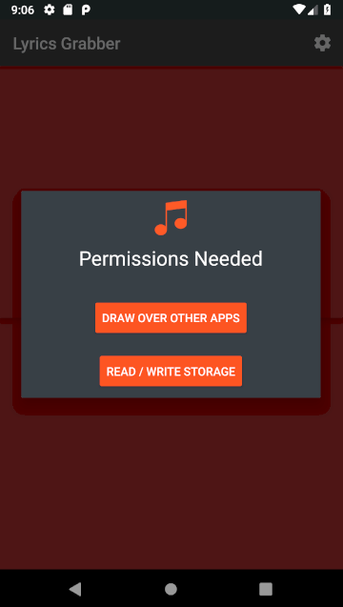

Figure 20: Start up

The Figure above shows the start up after the installation of the application. And in the above figure the app will show a permissions needed box to read and write on the storage and draw over the other apps presented in mobile.

**Installation**

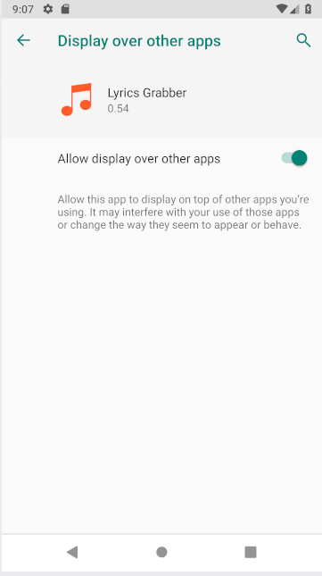

Figure 21: installation

The Figure above shows about the option after the start-up. This is where the user have to allow the application to display over the other apps so the lyrics can be generate when there is another app running in the background.

**Home**

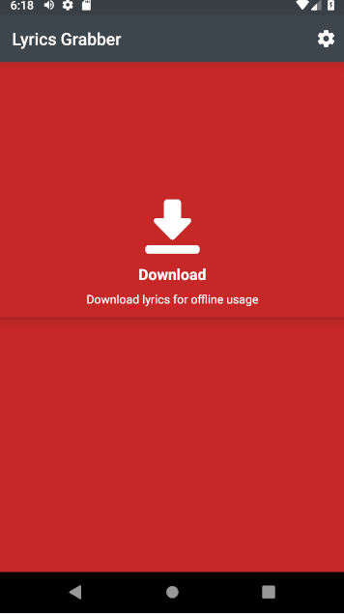

Figure 22: Home

The Figure above shows about is the front display of the application by pressing the download button you can download the lyrics of the song. This is the background of the application in which there is the download button to download lyrics.

**Download Lyrics**

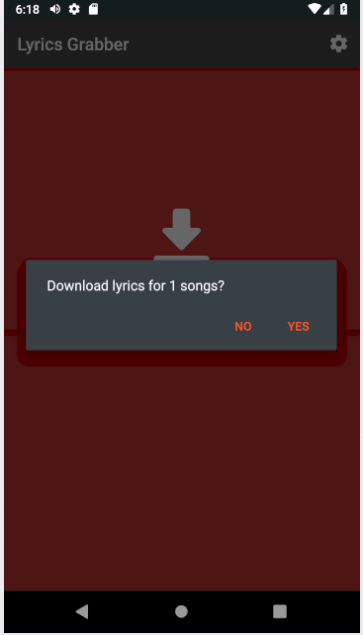

Figure 23: Download lyrics

The Figure above shows about the download option. This is where the users have to press the download button and a box shows to weather download lyrics of the song. After that, the users just have to press the yes then the download starts.

**Downloading**

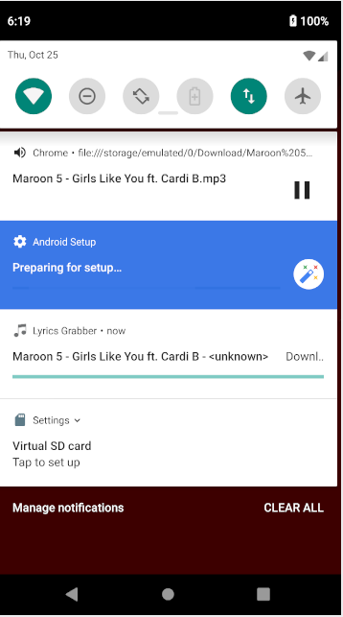

Figure 24: Downloading lyrics

The Figure above shows that application is going to download lyrics of the song. The user has to scroll down the top bar to see whether the lyric is downloading or not. After that, the users just have to press the lyrics grabber icon to view lyric.

**Shows Lyrics**

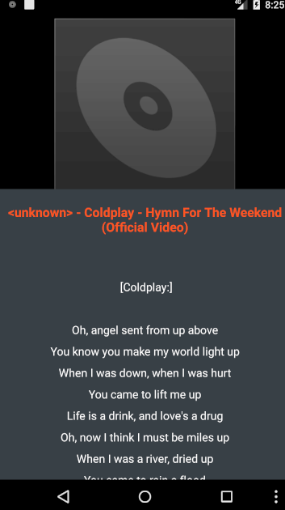

Figure 25:Lyrics show

The Figure above shows about the lyric popping up in the screen. This is where the user gets the lyrics of the song with the help of internet when the lyrics grabber button is clicked and it show the lyrics and it can be off by scrolling down lyrics pattern.

## 9.2 Sample codes

9.2.1 Start up

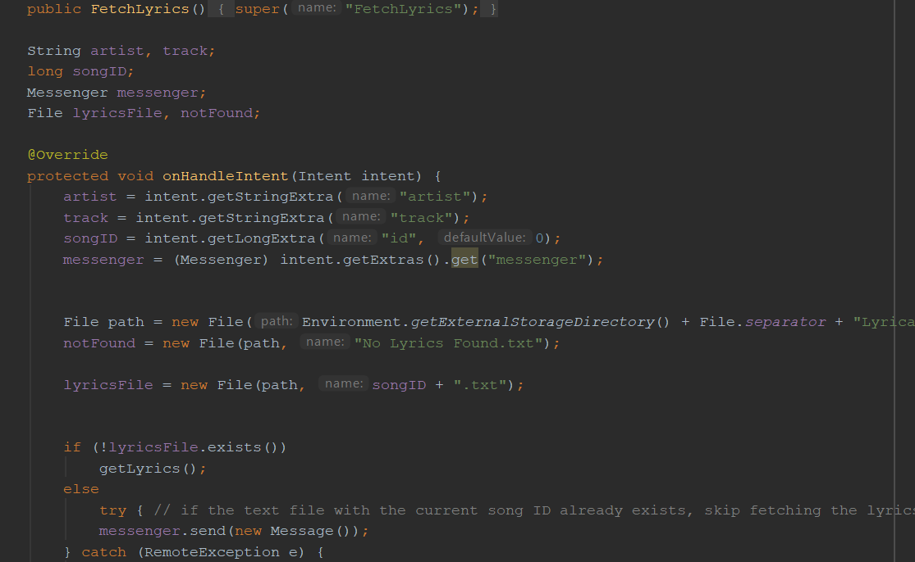

Figure 26: Start up code

**Download**

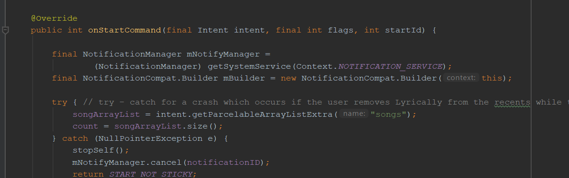

Figure 27: Download code

**Shows lyrics**

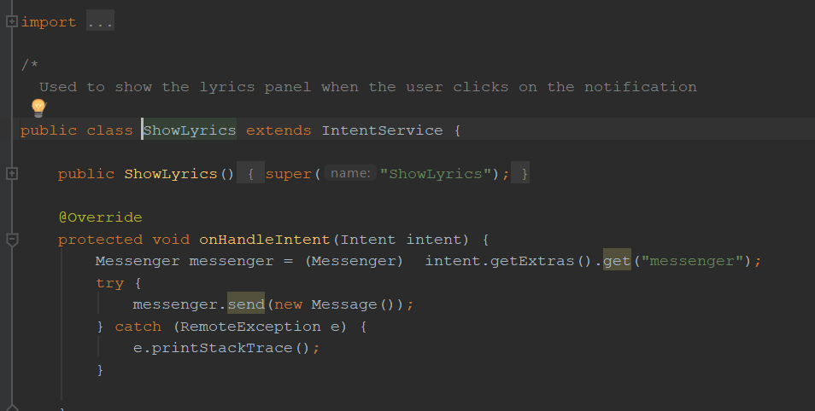

Figure 28:Shows Lyrics

**Main Activity**

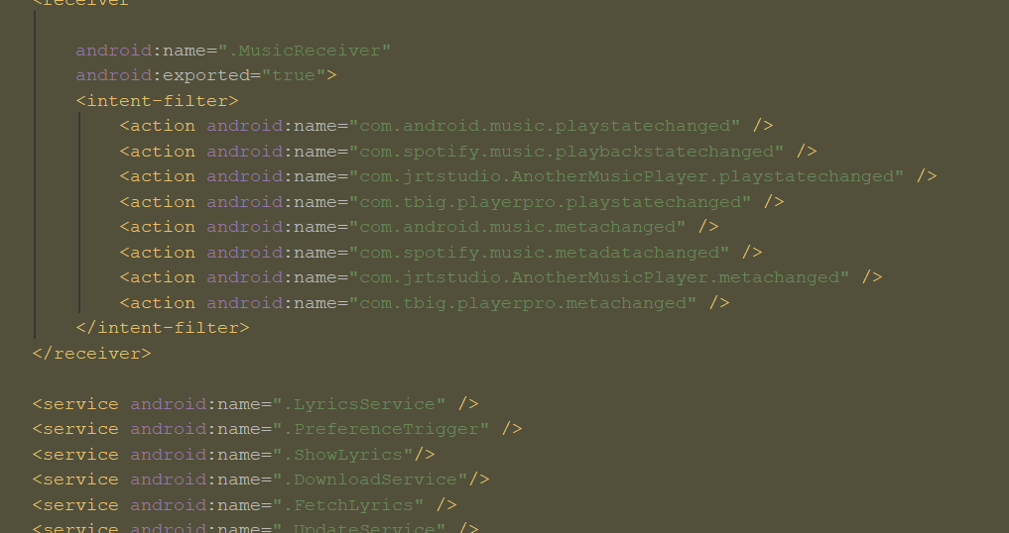

Figure 29: Main activity

**ID Tracker**

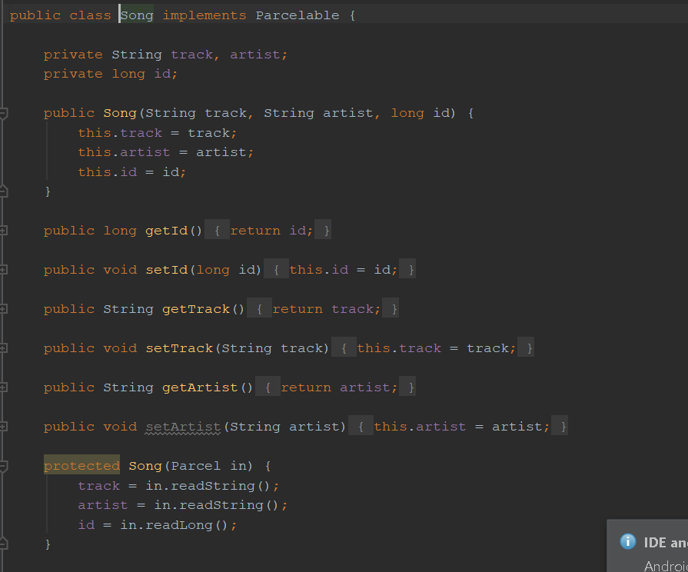

Figure 30: Song ID tracker code

# 10 System Validation

|  |  |  |  |  |  |
| --- | --- | --- | --- | --- | --- |
| **Download lyrics** | | | | | |
| Test No. | Test Condition | Description | Excepted Result | Actual Result | Status |
| 1 | Click button | Appear confirmation | Appear confirmation | pass |  |
| 2 | Press no | No download | No download | pass |  |
| 3 | Press yes | Starts download | Starts download | pass |  |

Table 6: Validation download lyrics

|  |  |  |  |  |  |
| --- | --- | --- | --- | --- | --- |
| **Shows Lyric** | | | | | |
| Test No. | Test Condition | Description | Excepted Result | Actual Result | Status |
| 1 | Click download button | Appear confirmation | Appear confirmation | pass |  |
| 2 | Press no | No download | No download | pass |  |
| 3 | Press yes | Starts download | Starts download | pass |  |
| 4 | Shows lyrics | Pops up lyrics | Pops up lyrics | pass |  |

Table 7: Validation of shows lyrics

## 10.2 User Acceptance Testing

User Acceptance Testing

Name: __Sunil Aryal___________ Address: _Boudha________

Phone No.: __9841667788________ Date: ___5th oct 2018_________

|  |  |  |  |  |  |  |  |  |  |  |  |
| --- | --- | --- | --- | --- | --- | --- | --- | --- | --- | --- | --- |
| Category | Poor (0-3) | | | | Adequate (4-7) | | | | Excellent (8-10) | | |
| 0 | 1 | 2 | 3 | 4 | 5 | 6 | 7 | 8 | 9 | 10 |
| Design of system |  |  |  |  |  |  |  |  | √ |  |  |
| Speed of system |  |  |  |  |  | √ |  |  |  |  |  |
| Easy to use |  |  |  |  |  | √ |  |  |  |  |  |
| Consistency |  |  |  |  | √ |  |  |  |  |  |  |
| Satisfied with  Overall perform. |  |  |  |  |  |  | √ |  |  |  |  |
| User Comments:  Very much easy to use the system. Satisfaction is very high provided by the system. Need to focus on speed of the system other all is ok. | | | | | | | | | | | |
| Action taken by the developer: | | | | | | | | | | | |

User Acceptance Testing

Name: __Anup Baral___________ Address: __kalanki_______

Phone No.: ____9841977877______ Date: ____6th oct2018________

|  |  |  |  |  |  |  |  |  |  |  |  |
| --- | --- | --- | --- | --- | --- | --- | --- | --- | --- | --- | --- |
| Category | Poor (0-3) | | | | Adequate (4-7) | | | | Excellent (8-10) | | |
| 0 | 1 | 2 | 3 | 4 | 5 | 6 | 7 | 8 | 9 | 10 |
| Design of system |  |  |  |  | √ |  |  |  |  |  |  |
| Speed of system |  |  |  |  |  | √ |  |  |  |  |  |
| Easy to use |  |  |  |  | √ |  |  |  |  |  |  |
| Consistency |  |  |  |  | √ |  |  |  |  |  |  |
| Satisfied with  Overall perform. |  |  |  |  |  | √ |  |  |  |  |  |
| User Comments:  Satisfactory Need to devolve more consistency. | | | | | | | | | | | |
| Action taken by the developer: | | | | | | | | | | | |

User Acceptance Testing

Name: ___Safalsarthak__________ Address: ___nakhipot______

Phone No.: __9843123251________ Date: ___7th oct2018_________

|  |  |  |  |  |  |  |  |  |  |  |  |
| --- | --- | --- | --- | --- | --- | --- | --- | --- | --- | --- | --- |
| Category | Poor (0-3) | | | | Adequate (4-7) | | | | Excellent (8-10) | | |
| 0 | 1 | 2 | 3 | 4 | 5 | 6 | 7 | 8 | 9 | 10 |
| Design of system |  |  |  |  |  | √ |  |  |  |  |  |
| Speed of system |  |  |  |  | √ |  |  |  |  |  |  |
| Easy to use |  |  |  |  |  |  |  |  |  |  |  |
| Consistency |  |  |  |  |  |  |  |  | √ |  |  |
| Satisfied with  Overall perform. |  |  |  |  |  |  |  |  | √ |  |  |
| User Comments:  Very much easy to use the system. Satisfaction is very high provided by the system. | | | | | | | | | | | |
| Action taken by the developer: | | | | | | | | | | | |

# 11. Reflection

## 11.1 Critical evaluation

By having Lyrics Grabber, the developer was able to solve the traditional ways of finding the lyrics of the song. One of the problems that the developer found out was the people who are not able to find the lyrics of the songs. Then people have to buy lyrics in the books and they have to carry the list of the lyrics they like this burden was seen more often in many people who are fond of the music.

Therefore, Lyrics Grabber allows the people to get lyrics of the song at anywhere. After that, the system also allows the user to view lyrics of the song which is included in playlist and can give feedback. Then, it also allows the userto download the lyrics of the song.

In the other words, the system is successfully built and it can achieve the main objectives. By using the mobile based system, the students, the user can use it anywhere as they like. Even though the system could be implemented with lots of extra features in it, still, the developer could manage to fulfill the basic requirement Lyrics Grabber.

## 11.2 Limitations

As the project is built, the limitations in this Lyrics Grabber are a system is the system can only accept individual user.

For the downloading process, firstly the user has to download the the lyrics into their device. Without download process, the system cannot shows the lyrics of the song when it is not connected to internet. The system only able to accept some countries songs.

## 11.3 Future Enhancement

For further enhancement, the lyrics grabber will allow the user to use the app when it is offline.

For user development, the user will able to use it also when it is offline. Then the user can directly save the lyrics whenever they used the application. Therefore, the user does not need to download the lyrics of the song eventually whenever they use the apps.

# Conclusion

The research generates various ideas to implement for the future enhancements to tackle and overcome the conflicts occurred previously. However, it was managed to gain the sufficient technical comparisons that emitted that comprehensive understanding to support idea with its development phase. The awareness of the developer regarding the proposed system consciously increased, hence it is a benefit due to this and impact will be positively rendered to the system.

To finished the report the developer have to write huge proposed system required huge extensible notes with an appropriate different study about cases however it know that the search of the study will helped the developer in building the future informative plans. The research generates various ideas to implement for the future enhancements to tackle and overcome the conflicts occurred previously. However, it was managed to gain the sufficient technical comparisons that emitted that comprehensive understanding to support idea with its development phase. The awareness of the developer regarding the proposed system consciously increased, hence it is a benefit due to this and impact will be positively rendered to the system.

# 12. Appendix

## 12.1Questionnaire

These are the number of questions to be asked to the users or clients of Lyrics Grabber.

Marital Status: Age:

Gender:

Occupation:

**Random people**

1. How do you find searching lyrics of song??

* Easy
* Difficult
* Very difficult

1. There is app named musicXmatch have you ever used it?

* Used several times(good)
* Never heard
* Used (Not reliable)
* N/A

1. Are you fond of music?

* Yes
* Satisfactory
* No
* N/A

1. Do you love music?

* Yes
* Satisfactory
* No
* N/A

1. How useful do you find to use musicxmatch?

* Good
* Satisfactory
* Not useful
* Never heard

1. Would you be interested in using this kind of app?

* Interested
* Not interested
* N/A

1. How do you rate this kind of app will be useful?

* Excellent
* Satisfactory
* Poor
* N/A

1. Will it be useful or fun to you?

* Yes
* No
* N/A

**Questionnaires for Musician/artist**

1. How do you find lyrics of a particular song?

* Difficult
* Take help of internet
* No answer

1. Is it hard?

* Yes
* Satisfactory
* No
* N/A

1. Have you ever thought of using an app which can generate lyrics of songs?

* Sometimes
* No
* Used few times, not useful
* N/A

1. Would you be interested in using this kind of app?

* Interested
* Not interested
* N/A

1. How do you manage your playlist?

* properly
* mix max
* N/A

1. Can you find lyrics of all generic music lyrics?

* Yes
* No
* Don’t know
* N/A

1. Will it will be helpful to you?

* Yes
* No
* N/A

1. Have you ever find hard to get lyrics of songs?

* Yes
* No
* Sometimes
* N/A

1. Did finding lyrics of song is time consuming or not?

* Yes
* No
* Sometimes

1. Will lyrics grabber be able to exist in the current market?

* Yes
* No
* Don’t know
* N/A

1. Will this app will be helpful or not?

* Yes
* Frequently
* No
* N/A
* N/A

## 12.2 PPF

**FYP TITLE**

**Lyrics grabber**

**Introduction**

Lyrics Grabber is the application which generates the lyrics of song from playlist.

This project is about developing android application which helps to generate the lyrics of song. It will provide the lyrics of the song which is useful to music user artist and musician as well as random people. “Lyrics Grabber” is an android application which will provide lyrics of song.

With the help of this application any one can get the lyrics of song as the required.

**Problem Statement**

This is the application which is in past days we have to hard to get the lyrics of song we have to search lyrics of each and every song. Which consumes more time there are many people who find to get the lyrics of a particular song and to get to know about song lyrics many artist have find that it’s hard to get the lyrics of the song of different nation they have to surf and consume more time to get the lyrics .Even the artist musician I know faces the same problem to find the lyrics of the particular song.

And people who are fond of music cannot get to know about the lyrics as we know all the people have different taste of music and all people like the music get to know about the lyrics but some are busy and for them this mobile app will help to get the music lyrics on their smart phone easily.

**Project Aim**

The aim of this project is to develop the flexible and user-friendly android application to provide android application.

**Project Objectives**

To accomplish the aim of this project, there are several objectives that need to be achieved are as follow:

* Consult with application developer to understand the process of app development briefly.
* Develop the application by using Java programming language and Net Beans.
* Collect data to upload in application.
* Review of artist is needed.

**Literature Review**

If all the information of colleges is available online then it will be very helpful for students. It will save time and money of the persons. (Anon., 2017) Web application should run in many web browsers. Different web browsers have different features and function, so web application must be compatible with different web browsers. (Anon., 2017) The volume of online content continues to grow at a rapid rate. In May 2011 Google indexed an estimated 35 billion web pages. In May 20131 this has risen to 45 billion, with much of this content being free to access. (Anon., 2017) The rapid growth of the Internet and the emergence of worldwide economic entities have captured the attention of institutions, legislators and regulators. With increase in competition between educational institutions there is a lot of bias news about colleges. (Anon., 2015) The introduction of e-learning and online resources enables a greater degree of flexibility in providing support for the diverse demands of these students. (Anon., 2017) Web applications run through web browsers like Google Chrome. The program runs on a web server, rather than on the PC, or local server for traditional applications. Web application pages interact and respond with users requests, unlike basic website pages where pages are all pre-formatted. The most common example is online shopping application. (Anon., 2017)

**Deliverable**

**Target User**

The project makes the active involvement of the music lovers. Thus, the target user of this program is the particular person who is fond of music. The group can be identified on the basis of their current enrollment of them on various music fields as well as the other interested candidate for some sort of music. Similarly, the artists who have their own band and plays in pub will find it more properly lyrics of the song and can be useful to them.

**Expected deliverable**

The major deliverables of this project would be the mobile application with different functionalities as per the project requirements. The expected deliverables of the program thus are:-

•Mobile Application

**Mobile Application (Android)**

The mobile application is the priority product to be delivered as per the present market demand. The android based mobile application is supposed to fulfill the present requirements of the project. Java is to be used for the development of the beautiful and powerful mobile application with the addition of the many required features.

The features and working mechanism in mobile and web application are supposed to be similar. The only difference here could be the use of different platform.

Name of Supervisor: Mr. RN THAKUR

## 12.3 PSF

**Problem Context**

According to many artists they get hard to find the lyrics of the songs and have to spend more time in internet browsing to get the lyrics of song which often are in proper. For this frustration in finding the lyrics of song they have to open search engine and search for the lyrics of the song which consume more time than as usual.

Some of the problems are as follows:

* It is hard to get lyrics of particular song
* Loss of time
* Specific knowledge is needed
* Hard for nonnative English user
* Chances of getting wrong lyrics of song

**Rationale**

According to the problems stated above, an “Lyrics Grabber” will be a standalone android application in Nepal which allows to get the lyrics of the song. It will definitely reduce the time of people who seek for lyrics. By this mobile application it will easily for them to get the lyrics of the song. For the outcome of the android application, there are two types of benefits:

**Tangible Benefits:**

* Time saving, do not have to go through internet browsing.
* Easy to use

**Intangible Benefits**

* Much convenience for finding the lyrics of the song.
* It will be accurate.

**Nature of Challenge**

First of all, I need to fulfill the user experience. Different users might view the android application in different screen resolution, different handheld devices.Besides that, implementing a micro site on smart phone like iPhone will be part of the challenge on my project. While developing the android application, security of the application will definitely be taken into consideration. This project will be developing using JAVA programming language so, which will be the most challenging part on how to structure my project. The last but not least, information provided in the system must be accurate and unbiased.

**Brief description of project objectives**

**Deliverables**

This application “Lyrics Grabber” allows people to get the lyrics of the song in their personal handheld devices. By using these application people will get the lyrics of the song easily. This will save more time.

Below are the cores functions of the system will be achieved before delivering.

* Get the lyrics of the song.
* Saves time.
* Can be accessed easily.

**Hardware**

The minimum requirements for hardware for the personal computer to successfully carry out and meet the objectives of the system are as follows:

* Processor – Dual core
* Random Access Memory (RAM) – 512MB
* Touch screen
* Router (RJ45 / Wireless Fidelity (Wi-Fi))

**Software**

The minimum software requirements for the development and execution of the project are as follows:

Code Editor and Database Management System (DBMS)

* Sublime Text Editor
* JAVA

Server-Side Scripting, Web Server and File Transfer Protocol (FTP) Software

* Net Beans

**Documentation and Planning**

* Microsoft Project 2007
* Microsoft Word 2007

**Access to information / expertise**

The development of the system will require consultation from IT experts who are experienced in developing web applications and security field. Apart from that, information may be gathered from interviews and surveys done with musician artist random people.

**User Involvement**

The people who are involved are students, parents and colleges staffs. Different levels users like novice user, casual user and expert user will be involve. Apart from that, I will try to get feedbacks from students regarding to system, and also to college staffs. These users will be assisting on the usability testing phase. Academic researches being carried out and other information, techniques being learnt.

**References**

**Books**

Name: JAVAAndroid(4th Edition)

Author: Luke Welling, Laura Thomson

Publisher: Addison-Wesley Professional

Name: learning JAVA

Author: David Sklar

Publisher: O’Reilly Media

**System Development Methodology**

System development methodology is a framework that is used to structure, plan and control the process of developing an information system. It may include specialized forms for preparing the documentation describing each phase.

There are various choices of software development methodology and I have chosen two different software development methodologies which I think are the most suitable to structure, plan and control the development process. The first acceptable system development methodology will be Waterfall methodology. It is a linear framework type and the project will be divided into sequential phases, with some overlaps between each phases. The phase will be strictly controlled to ensure it is in sequence. For example, system design phase must be completed before proceeding to the coding phase. Besides that, it is an ideal methodology for supporting less experienced project managers and the progress of the system development can be easily been measure. Apart from that, another acceptable system development methodology will be Prototyping methodology. This will be slightly different with Waterfall methodology. In Prototyping methodology, project risk will be minimized by breaking the project into segments. Besides that, it helps to identify the problems at the early stage and refine the system to meets the users’ requirements or expectations. Other than that, it provides quick implementation; identify confusing or difficult functions and missing

**Resource required**

The development of the web and mobile application is the challenging context of the project. The development of this application requires the regular workout and knowledge in the field of the software development.

The hardware required for the development of the application are:

• Computer for the purpose of coding

• Data storage drive for the data transfer and other activities.

• Electricity and use of the internet.

The programming language used:

• Java for android development.

The software required in the development of the application are:

• Android studio for android application development.

• Microsoft word 2010

• Microsoft Visio 2010

• Microsoft Project 2010

The various resources required for the project are the general data from the internet, newspapers and television. The guidance of the supervisor along with other intellectual plays the major role in the development of the project. The different testing activities are carried out with the people of the interest in the area with the possible helps form the close ones.

The application will have different level of control. The guest panel, user panel and the admin panel are the preferred panel to carry out the different activities according to the respective responsibilities of the allocated user.

**Academic Research**

The list of the book I would prefer to study are as follows:

Book name: Introduction to Java Programming

Author: Y. Daniel Liang

Publisher: Pearson

**Book: A Head First Design Pattern**

Author: Eric Freeman and Elizabeth Freeman

Publisher: OReilly

**Book:Decompling Android**

Author: Godfrey Nolan

Publisher: APress

**Book: Expert PHP and MySQL**

Author: Patrick Galbraith, Andrew Curioso, Ronald Bradford

Publisher: Wrox

**Plan and Methodology**

The software development requires a definite plan and methodology. There are different kinds of software development methods to be applied for the successful development of software. As per the project I’ve chosen Waterfall methodology for the software development methods.

**Waterfall Development Methodology:**

Waterfall Software Development is an approach that is used to design a disciplined software management process which also allows some frequent alteration in the development project. This is a type of software development methodologies which is one conceptual framework for undertaking various software engineering projects. It is used to minimize risk by developing software in short time boxes which are called iterations that generally last for one week to one month.

**Advantages of Waterfall Development Methodology:**

Waterfall methodology has an adaptive approach which is able to respond to the changing requirements of the clients

Direct communication and constant feedback from customer representative leave no space for any guesswork in the system

Disadvantages of Waterfall Methodology:

This methodology focuses on working software rather than documentation, hence it may result in a lack of documentation

The software development project can be hard to understand by client.

**Success Criteria**

The main target of “Lyrics Grabber” is to find the lyrics of the song. In order to make sure the system is functioning well before delivering, 5 artist and musician from generic field will conduct the testing as follows.

**Unit Testing**

In unit testing, a small part of a testable unit will be taken from the application, and tested to see whether it behaves exactly with the deliverables. Each unit will be tested separately and this would include open generate the lyrics.6 digits and not more than 10 digits. All these units must go through a testing phase before integrated into a component.

**Integration Testing**

In integration testing, two tested units are combined into a component. For example, when admin of the system adds new college then it will give notification to user about that.

**Usability Testing**

In usability testing, the satisfaction level of the end-users must be carried out. Participants of this testing phase will apply actual input on how real users use the system. Besides that, they will evaluate the system based on few aspects such as the graphical user interface (GUI), feedback message and the response time of the system. For example, the graphical user interface of the system needs to refine it if it is not user-friendly for a novice user and casual user.

Bibliography

agilemodeling. (2018). *http://www.agilemodeling.com*. Retrieved from http://www.agilemodeling.com/essays/agileRequirements.htm

Benharosh, J. (n.d.). *phpenthusiast*. Retrieved 2018, from https://phpenthusiast.com/

*business*. (n.d.). Retrieved from http://www.businessdictionary.com/definition/technical-research.html

citewrite. (2018). Retrieved from https://www.citewrite.qut.edu.au/write/litreview.jsp

Dan sayre, K. s. (2011). In k. santor (Ed.), *opreating System.* john wiely&sons,Inc.

*devjava*. (n.d.). Retrieved from https://www.journaldev.com/

digitalunite. (2016). *digitalunite*. Retrieved 2018, from https://www.digitalunite.com/guides/using-internet-0/searching-browsing/what-web-browser

Gail Anderson, P. A. (November 2014). In *The analysis conducted was a great stage of the research, thus the majority resulted with a positive response that encouraged the developer to provide a great degree of flexibility in the application.* , Addison-Wesley .

Hice, G. F. (1978). *System Development Methodology* (2 ed.). Elsevier Science Ltd.

itsadeliverything. (2018). *http://itsadeliverything.com*. Retrieved from http://itsadeliverything.com/agile-project-monitoring-and-control

Jackson, M. A. In *System development.* Michael Jackson Systems Limited.

javatpoin. (n.d.). *javatpoin*. Retrieved 2018, from https://www.javatpoint.com/mysql-features

*journaldev*. (n.d.). Retrieved from https://www.journaldev.com/7153/core-java-tutorial

Kręglewski, M. (2014). In *database.*

Naji, C. (2017). *justinmind*. Retrieved 2018, from https://www.justinmind.com/blog/4-prototyping-process-models-to-streamline-software-development/

navathe, e. (2010). In *fundamental database system.* Addison-Wesley.

rallydev. (n.d.). *https://help.rallydev.com*. Retrieved from https://help.rallydev.com/release-planning

*rlf.org*. (n.d.). Retrieved from https://www.rlf.org.uk/resources/what-is-a-literature-review/

Schäferhoff, N. (2016). *eleganttheme*. Retrieved 2018, from https://www.elegantthemes.com/blog/resources/the-sublime-text-code-editor-an-in-depth-review

*searchweb*. (n.d.). Retrieved from https://searchmicroservices.techtarget.com/deafinition/domain

*system*. (n.d.). Retrieved from https://www.munnellys.com/divisions/delivery-management-system-dms/607/

teamgantt. (2018). *www.teamgantt.com*. Retrieved from https://www.teamgantt.com/guide-to-project-management/how-to-plan-a-project

The Economic Times. (2015). web server. *The Economic Times* .

trello. (2018). *https://blog.trello.com*. Retrieved from https://blog.trello.com/beginners-guide-scrum-and-agile-project-management

tutorialspoint. (n.d.). *tutorialspoint*. Retrieved 2018, from https://www.tutorialspoint.com/html5/index.htm

tutorialspoint. (n.d.). *tutorialspoint*. Retrieved 2018, from https://www.tutorialspoint.com/css/css3_tutorial.htm

whichcmstochoose. (2014). *whichcmstochoose*. Retrieved 2018, from http://whichcmstochoose.com/wordpress.html